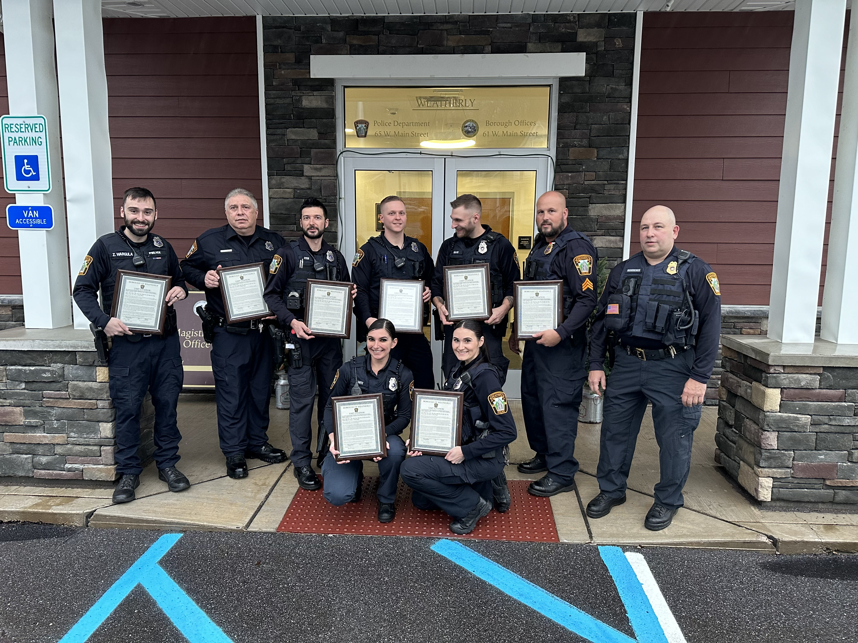

2023

Annual Report
Weatherly Police Department
570-427-4241  weatherlypd.com | 65 West Main Street  Weatherly, PA. 18255 | 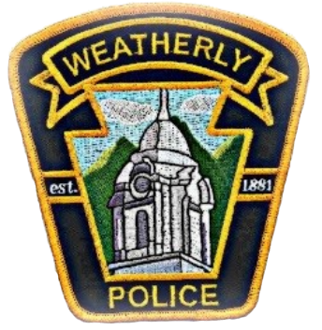
TABLE OF CONTENTS

Message from the Chief _____________________________________________________3
Mission Statement _________________________________________________________ 4
Overview of Weatherly ______________________________________________________5
Police Department Roster___________________________________________________ 6
Police Department Fleet_____________________________________________________ 8
School Resource Officers____________________________________________________ 9
School Safety Zone_________________________________________________________10
School Year Incident Reports_________________________________________________11
Public Information__________________________________________________________13
Assisting Other Law Enforcement Agencies_____________________________________ 14
Calls For Service___________________________________________________________16
Part I Offenses____________________________________________________________ 17
Part II Offenses___________________________________________________________ 18
Traffic Warnings___________________________________________________________ 19
Traffic Citations___________________________________________________________ 20
Parking Violations__________________________________________________________ 21
Vehicle Code Section Breakdown______________________________________________22
Impound Report____________________________________________________________24
Non-Traffic Citations________________________________________________________ 25
Criminal Arrests____________________________________________________________26
Officer Training____________________________________________________________ 28
Accreditation______________________________________________________________ 30
Community Outreach_______________________________________________________ 31

message from the chief

It is my pleasure to present the 2023 Weatherly Borough Police Departments annual report.

The Weatherly Borough Police Department provides a wide range of services to the borough. Our goal being to provide effective, accountable policing and criminal justice practices to enhance the public safety and trust. We attempt to use proactive solutions to correct quality of life issues before those issues become criminal or community wide.

Please take the time to read this report and gain a better understanding of the job the Officers do daily and the service we provide. The Department will continue to work with residents and elected officials to remedy problems as they arise and to improve the quality of life within the Borough of Weatherly.

Transparency and public interpretation are essential to our success. Thank you for taking the time to read this report.

Chief Brian Markovchick
Weatherly Borough Police Department

mission statement

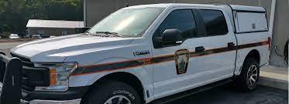

It is our mission to provide the quality of life by providing the highest level of professional police service through a partnership with the community. We are committed to creating a safe, crime free environment by enforcing the laws of the Commonwealth of Pennsylvania and the U.S. Constitution. We will accomplish this by practicing our core values of integrity, professionalism and respect.

Integrity
The quality of being honest and having strong moral principles; moral uprightness

Professionalism
The competence and skill expected of a professional

Respect
Due regards for feelings, wishes, rights or traditions of others

Weatherly overview

County
- Carbon

Population
- Approximately 2,600 Residents

Map
- Weatherly is just 8 miles southeast of Hazleton
- 12 miles northwest of Jim Thorpe
- 28 miles south of Wilkes-Barre

Police Department Allocations
- 6 Full-time Officers
- 7 Part-time Officers

History of the Borough
Weatherly was founded in 1825 by Benjamin Romig through the purchase of a 400-acre piece of land. The Borough was then incorporated on October 8th, 1863. The Borough began as a haven for the timbering industry and proceeded to expand with the development of the railroad and transportation of coal.
The Borough is situated at an elevation of 1,100 feet in the Ridge and Valley Province of the Appalachian Mountains between Spring Mountain and Round Head Mountain to the north and Broad Mountain to the south. Weatherly has a down-home, small town feel and remains a community of people that love their legacy, cherish the wholesome lifestyle and take in the beauty of the natural surroundings.

police department roster

Chief Brian Markovchick |  |   Sergeant Michael Bogart

  Officer Edward Kubert |   Officer Joshua Silfee |   Officer Michael Eyer

police department roster

  Officer Ashley Harris |   Officer Sofia Hantz |   Officer Jonathan Yaskiewicz

  Officer Christopher Belles | Officer Nicola Palermo |   Officer John Molosky

police department fleet
The Weatherly Police Department currently maintains a fleet of Ford and Dodge police vehicles. The department has several fully marked vehicles for patrol operations. The department also has unmarked vehicles that are utilized for patrol and special operations. The department also secured a fully operational crimes scene unit as well as all-terrain vehicles for specialized needs of the department.

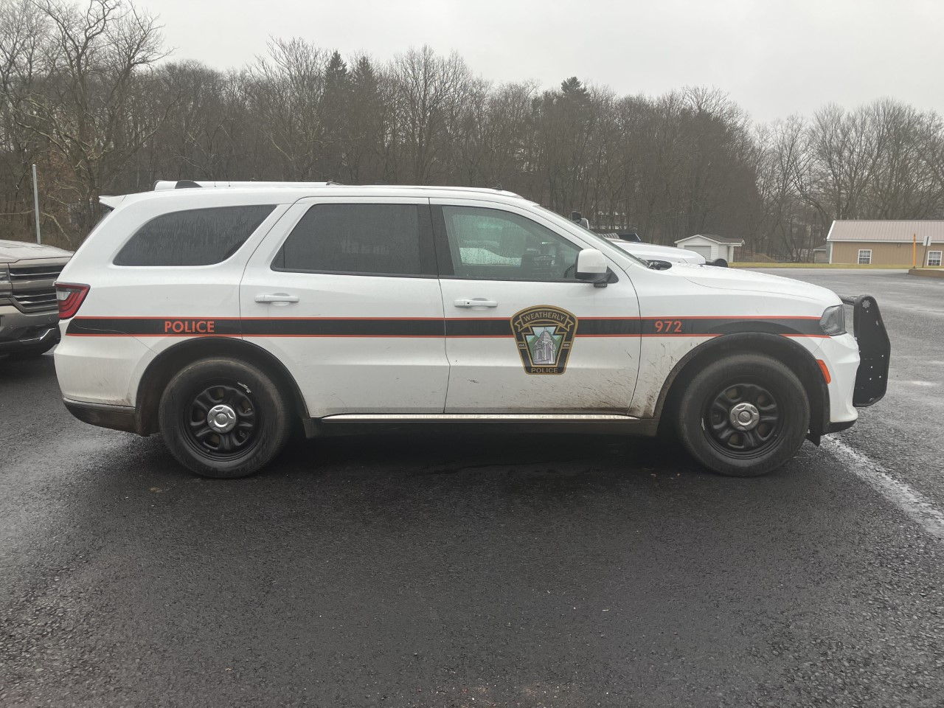
All vehicles utilized for patrol are equipped for the everyday tasks to protect not only the citizens of Weatherly but the surrounding communities when assistance is requested. The vehicles are equipped with computers, video/audio recording devices, radios, medical and trauma supplies, fire suppression equipment, patrol rifles, shot guns and spike strips.
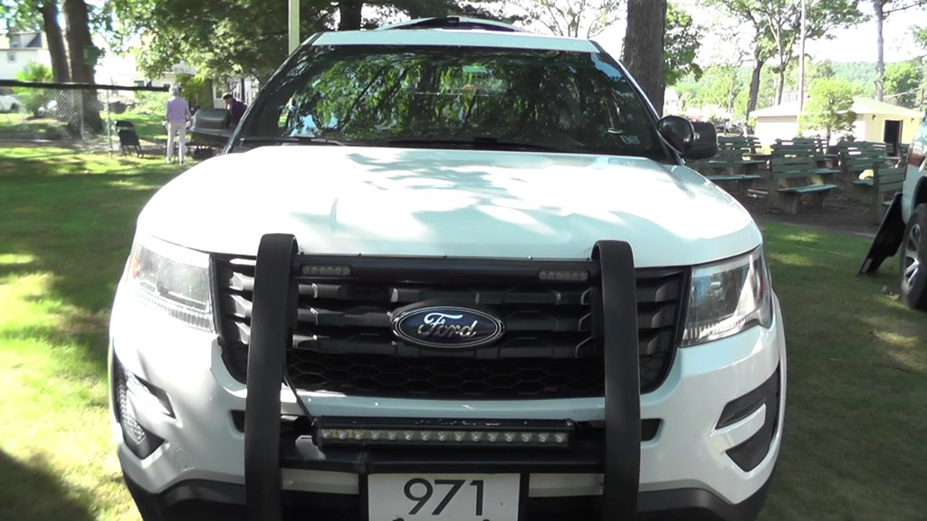
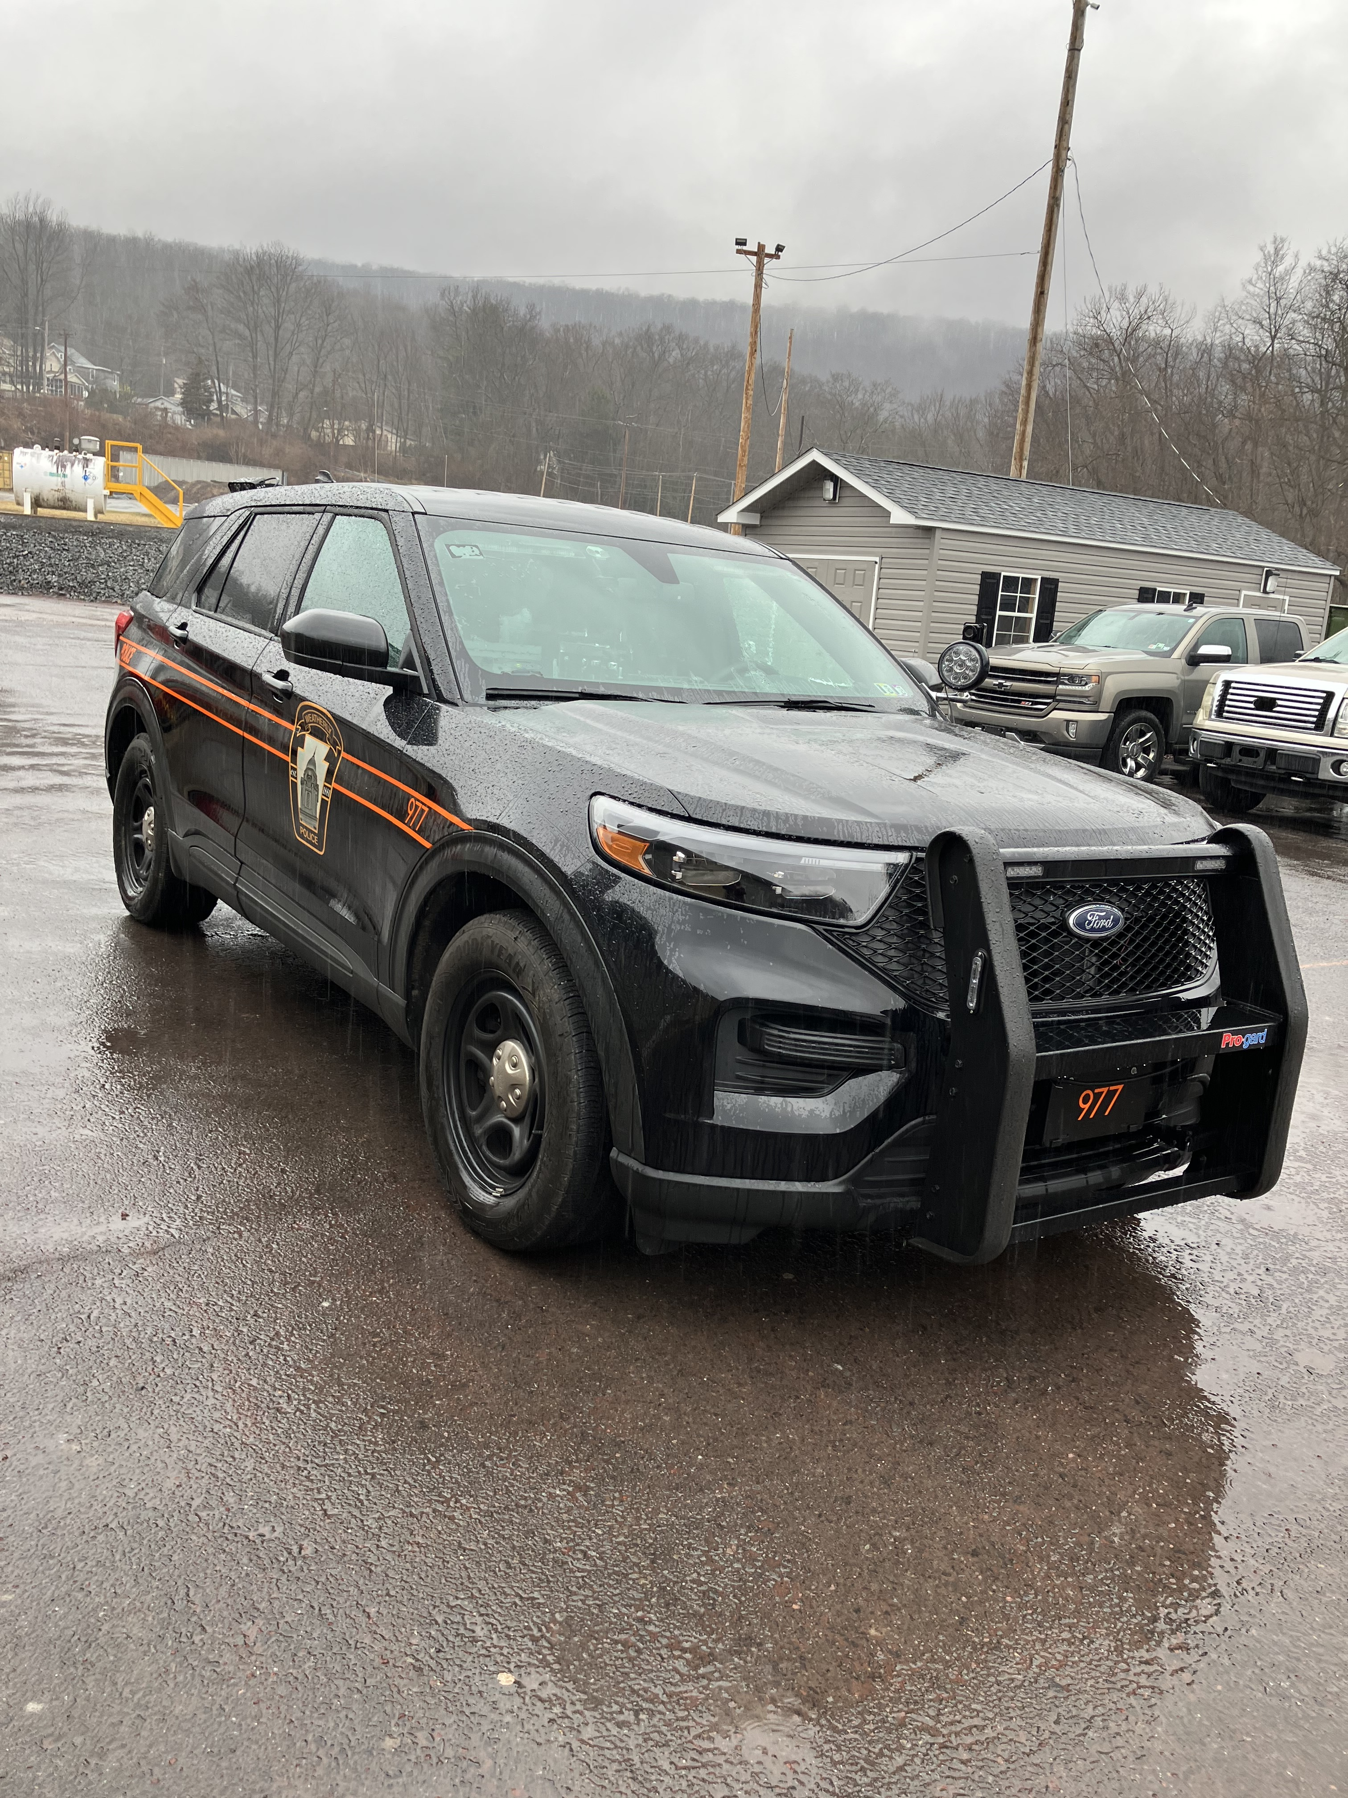

- Marked Patrol Unit 971: 2016 Ford Interceptor
- Marked Patrol Unit 972: 2022 Dodge Durango
- Marked Patrol Unit 974: Mobile Crime Scene Unit
- Marked Patrol Unit 975: 2020 Ford F-150
- Marked Patrol Unit 977: 2022 Ford Interceptor
- Unmarked Patrol Unit 973: 2010 Ford F-150

school resource officers

The School Resource Officers Program was implemented in the Weatherly Area School District in November 2022 by mutual consent and agreement between the Borough of Weatherly and the Weatherly Area School District.

Both parties agreed that it has been and shall continue to be the primary mission of the Weatherly Borough Police Department and the Weatherly Area School District School Officers Resource Program to provide a united and cooperative effort to prevent crime, disorder, drug activity, gang activity, and violence in and around the schools of Weatherly. We shall reach this goal and fulfill our mission through education, awareness, enforcement, innovation, open communication and cooperation between all parties.

The School Resource Officers Program Command Center is located in the Weatherly Area Elementary/Middle School. The Command Center is home to advanced equipment which allows the Officers to better look out for the safety of both students and staff.

school zone safety

The Borough is composed of three schools in the Weatherly Area School District. The public school district in Carbon County is centered in Weatherly and also serves the Borough of East Side along with Lehigh, Packer, Lausanne and Northern Kidder Townships.

The district features one elementary, one middle and one high school. The School Resource Officers provide routine patrol throughout the school day and targeted enforcement of both pedestrian and vehicular traffic during the arrival and dismissal of students each day.

Other duties of the SRO include periodic checks and walk-throughs of all schools, checking in with faculty and staff and making sure all doors, entrances and exits are secured. The SRO also has the opportunity to interact with the student body making for a more positive and safer environment which promotes better community relations.

Weatherly Police try to leave a positive impact on students despite unique and increasing challenges placed on our youth today.

2023 school year incident reports

Assist Other Agencies…………………………………………………………………………………………………………………………………………3
Parking Violations………………………………………………………………………………………………………………………………………………….2
Open Doors/Windows-Discovered………………………………………………………………………………………………………………12
Non-Criminal-Suspicious Persons/Autos…………………………………………………………………………………………………..6
Suspicious Persons, Autos, Circumstances……………………………………………………………………………………………10
Medical Emergency……………………………………………………………………………………………………………………………………………..7
SRO Assist…………………………………………………………………………………………………………………………………………………………….27
Harassment…………………………………………………………………………………………………………………………………………………………..13
Police Info, Notifications…………………………………………………………………………………………………………………………………….4
Fire Alarms (Founded/Unfounded)……………………………………………………………………………………………………………….3
Administration-Training Given…………………………………………………………………………………………………………………………1
Disorderly Conduct……………………………………………………………………………………………………………………………………………….4
Threats (Kill, Bomb, Phone, etc.)…………………………………………………………………………………………………………………..8
Disturbances-Juvenile………………………………………………………………………………………………………………………………………..4
Disturbances-Other………………………………………………………………………………………………………………………………………………1
Administration-Other……………………………………………………………………………………………………………………………………………2
Theft-Attempted…………………………………………………………………………………………………………………………………………………….1
Service Call-Alarms……………………………………………………………………………………………………………………………………………..5
All Other Crimes Code Violations…………………………………………………………………………………………………………………..2
Non-Criminal-Water leaks, Mains, etc………………………………………………………………………………………………………….1
Fingerprinting…………………………………………………………………………………………………………………………………………………………..1
Traffic Enforcement-Complaint………………………………………………………………………………………………………………………..5
Traffic Related Escorts…………………………………………………………………………………………………………………………………………2
Traffic Related-Motorists Aid……………………………………………………………………………………………………………………………..1
Drug Equipment Violations…………………………………………………………………………………………………………………………………1
Departmental Services-Sentinel……………………………………………………………………………………………………………………15
Narcotics……………………………………………………………………………………………………………………………………………………………………..4
Trespassing………………………………………………………………………………………………………………………………………………………………..1
Lost and Found………………………………………………………………………………………………………………………………………………………….1
Lost/Missing Persons………………………………………………………………………………………………………………………………………………1
Traffic Accidents………………………………………………………………………………………………………………………………………………………..1

Criminal Mischief………………………………………………………………………………………………………………………………………………………1
Weapons………………………………………………………………………………………………………………………………………………………………………1
Sex Offenses……………………………………………………………………………………………………………………………………………………………..4
SRO Assist……………………………………………………………………………………………………………………………………………………………….26
Open Doors/Windows………………………………………………………………………………………………………………………………………….12
Pornography/Obscene Materials………………………………………………………………………………………………………………………2
Mental Health…………………………………………………………………………………………………………………………………………………………….1
Assault………………………………………………………………………………………………………………………………………………………………………….1
911 Open Line or Hang Up………………………………………………………………………………………………………………………………….2
Use of Tobacco/Vape…………………………………………………………………………………………………………………………………………..13
Kidnapping/Abduction…………………………………………………………………………………………………………………………………………….1
Offenses Against Family/Children…………………………………………………………………………………………………………………….2
Administrative Duties……………………………………………………………………………………………………………………………………………..7
Traffic Enforcement…………………………………………………………………………………………………………………………………………………5
Pedestrian Contacts………………………………………………………………………………………………………………………………………………..2
All Other Offenses……………………………………………………………………………………………………………………………………………………3
Littering…………………………………………………………………………………………………………………………………………………………………………1

public information

Residents who live in the Weatherly Borough Police Department’s jurisdiction have access to numerous resources. Citizens can come to the station to speak with officers about issues that concern them and their neighborhood.

The Police Department also has a secure cabinet for medication drop off located in the main lobby of the Weatherly Borough building and police station. It can be accessed 24 hours a day, 7 days a week, 365 days a year. Pills can be left in original containers or placed in a bag. Please refrain from dropping liquids, saves, needles and creams in the box.

The department collected approximately 57 lbs. of pills in 2023.

When you are planning time away from your home whether it be for vacation or any other reason, the Weatherly Police Department will periodically check your residence and notify you or your designee if any serious problems are discovered. Property checks are offered to Weatherly residents free of charge. Property checks submissions must have a start and end date specified. A perimeter check consisting of a physical and or/visual check of all doors and windows will be conducted as well as a verification of vehicles left on the property.

Just a reminder that the property check service is NOT a guarantee that the property is safe or that it will not be burglarized. It is also not a substitute for an alarm system. The service can’t be provided for properties in which someone is staying at the residence.

Residents can also visit the departments website at www.weatherlypd.com to access and download other documents including right to know requests and monthly incident reports.

assisting other law enforcement agencies

The Weatherly Borough Police Department is comprised of several men and woman who work day in and day out to provide the best services possible to the Borough of Weatherly. The officers also have the same dedication and core values when called upon to provide assistance to their agencies and communities. It is an honor to have such a great working relationship with not only neighboring departments but also neighboring states as well.

Weatherly Police Department assists numerous state and federal agencies on a multitude of different calls and incidents. Some of these agencies require types of assistance that only our department can offer such as use of specialized equipment, working as part of a designated task force or use of technology that nobody else in surrounding areas possess like a mobile fingerprint identification device. It is not without the great team work of all agencies that we keep our communities safe!

The Weatherly Police Department assisted state, federal and local law enforcement agencies a total of 93 calls for assistance.

The Weatherly Police Department had a call volume of approximately 3,577 incidents
for the year 2023. These calls and incidents range in severity from traffic warnings, domestic disturbances, narcotic offenses, DUI’s and violent crimes.

Part I crimes as defined by the FBI are criminal homicide, forcible rape, robbery, aggravated assault, burglary, grand theft auto and arson. The Uniform Crime Reporting reports Part I crimes in term of both crimes known to police and arrests. Part one crimes are reported in terms of arrests

Part II crimes are defined by the FBI as forgery, fraud, simple assault, DUI, drug abuse violations and disorderly conduct. Part II includes, but is not limited to, some victimless crimes.

A total of 498 traffic warnings were given for motor vehicle violations in 2023.

A total of 308 traffic citations were given for motor vehicle violations in 2023.

A total of 40 parking violations were issued in 2023.

vehicle code section breakdown

3362. Max Speed……………………………………………………………………………………………………………………………………………………61
3323. Stop Signs…………………………………………………………………………………………………………………………………………………….32
1301. Registration and certificate of title required…………………………………………………………………………………..52
4703. Operation of vehicle without official certificate of inspection………………………………………………….36
1371. Operation following suspension of registration…………………………………………………………………………….17
1786. Required financial responsibility………………………………………………………………………………………………………….12
1501. Drivers required to be licensed…………………………………………………………………………………………………………….34
1543. Driving while operating privilige is suspended or revoked……………………………………………………….30
4305. Vehicular hazard signal lamps………………………………………………………………………………………………………………21
3354. Prohibited parking in specified places……………………………………………………………………………………………….12
3714. Careless driving……………………………………………………………………………………………………………………………………………..4
7124. Fraudelent use of a registration plate……………………………………………………………………………………………………1
3709. Depositing waste on highway……………………………………………………………………………………………………………………1
4107. Unlawful activities……………………………………………………………………………………………………………………………………………1
3351. Stopping outside………………………………………………………………………………………………………………………………………………1
7711. Registration of an ATV………………………………………………………………………………………………………………………………….4
4524. Windshield obstruction and wipers………………………………………………………………………………………………………….4
3305. Limitations on overtaking on left……………………………………………………………………………………………………………….1
3717. Trespass by motor vehicle……………………………………………………………………………………………………………………….13
3308. One-way roadways and rotary traffic islands……………………………………………………………………………………..4
7730. ATV liability insurance………………………………………………………………………………………………………………………………….3
7726. Operation of an ATV in a safe manner………………………………………………………………………………………………….1
3334. Required position and method of turning…………………………………………………………………………………………….1
1511. Carrying and exhibiting Drivers license on demand……………………………………………………………………….2
3111. Obedience to traffic control devices……………………………………………………………………………………………………….3
4581. Restraint systems……………………………………………………………………………………………………………………………………………2
3310. Following to closely……………………………………………………………………………………………………………………………………….1
1574. Permitting unauthorized person to drive……………………………………………………………………………………………….2
3301. Driving on right side of roadway……………………………………………………………………………………………………………….1
3342. Obedience to train signals………………………………………………………………………………………………………………………….1
4702. Prohibitions on emission inspections…………………………………………………………………………………………………….2

7122. Permitting violation of a title…………………………………………………………………………………………………………………….3
1376. Failure to surrender registration plate upon suspension…………………………………………………………….1
7124. Unauthorized transfer or use of a registration plate……………………………………………………………………..3
3736. Reckless driving…………………………………………………………………………………………………………………………………………….1
4305. Turning movement required signal……………………………………………………………………………………………………….1
3313. Restriction on use of highway/bridges………………………………………………………………………………………………..6
3325. Duty of driver on approach of emergency vehicle………………………………………………………………………….1
3307. No passing zone…………………………………………………………………………………………………………………………………………….1
3743. Accidents involving damage to properties………………………………………………………………………………………….3
4301. General lighting equipment required…………………………………………………………………………………………………….1
4727. Issuance of cerificate of inspection………………………………………………………………………………………………………..1
4523. Exhaust system, mufflers and noise control……………………………………………………………………………………….1
4525. Tire and traction equipment surfaces…………………………………………………………………………………………………….1
3702. Limitations on backing………………………………………………………………………………………………………………………………….1
3365. School zone speeding………………………………………………………………………………………………………………………………….2
3746. Immediate notice to police of accident………………………………………………………………………………………………….1
3744. Duty to give information and render aid……………………………………………………………………………………………….1
4581. Restraint systems……………………………………………………………………………………………………………………………………………2
1336. Use of dealer registration…………………………………………………………………………………………………………………………….1
3105. Drivers of emergency vehicles………………………………………………………………………………………………………………….1

impound report

Weatherly Police Department is unique as it has its own impound lot which is managed solely by Weatherly Police personnel. A vehicle will be impounded if it was used in the commission of a crime or if it illegally parked at the time the violation occurs and it is unable to be removed to a location which is a legal parking zone, such as the operator not having a valid license.

A total of 82 vehicles were impounded in 2023.

A total of 189 non-traffic citations were issued for 2023.

Criminal arrest in 2023

During the course of duty, Weatherly Borough Police Officers regularly arrest and/or place someone in custody. An arrest is the act of apprehending and taken a person into custody usually because the person is suspected of or observed in committing a crime. After being taken into custody, the person can be questioned further and/or charged. An arrest is a procedure in the criminal justice system.

In 2023, Weatherly Police Department arrested approximately 46 offenders. These crimes range in severity from narcotics possession to violent crimes. Approximately 21 offenders were placed in our holding cells located at the Weatherly Police Department. These criminal arrests added up to 161 criminal charges filed.

officer training

Training and education are key to Officers serving the Borough of Weatherly. The Department uses mandatory and elective training to keep Officers at the highest level of performance to serve the Borough. Some training is hosted by the Weatherly Police Department and other training sends Officers out to other facilities. In 2023, Officers of the Weatherly Police Department attended 1,090 hours of training. The Department’s in-service training consisted of use of force, ethics, bias training, handcuffing, tire deflation system, duty to intervene and body camera usage.

Course | Participants | Number of Hours | Total Hours
Tactical Communications/Realistic De-escalation | 5 | 15 | 75
MPOETC Criminal Investigations | 12 | 3 | 36
MPOETC Officer Wellness | 12 | 3 | 36
MPOETC Tactical Communications | 12 | 3 | 36
MPOETC Legal Updates 2023 | 12 | 3 | 36
CPR/First Aid | 12 | 8 | 96
Firearms Recertification | 12 | 8 | 96
Standardized Field Sobriety Testing | 3 | 24 | 72
AXON Taser Instruction | 1 | 16 | 16
NCIC Clean Recertification | 2 | 2 | 4
NA SRO School Resource Officer Certification | 1 | 40 | 40
Child Endangerment/Death Investigation | 2 | 8 | 16
Active Shooter Preparedness | 1 | 2 | 2
Active Shooter Level I TTT | 2 | 40 | 80
Social Media Exploitation | 1 | 8 | 8
Active Shooter Event Leadership | 2 | 2 | 4
Civilian Response to Active Shooter TTT | 1 | 2 | 2
Tint Meter Operation Course | 2 | 1 | 2
Drug Introduction/Conducting the Traffic Stop | 2 | 16 | 32
Enforcement of PA Vehicle Inspection Regulations | 5 | 16 | 80
Traffic Patrol Drug Introduction | 2 | 16 | 32

Course | Participants | Number of Hours | Total Hours
Taser Recertification | 11 | 8 | 96
Hazardous Material Awareness | 1 | 2 | 2
Toxic Gas Forming Reaction Awareness | 1 | 1 | 1
Introduction to Criminal Intention | 1 | 16 | 16
DWI Detection and SFST Instruction | 1 | 32 | 32
Law Enforcement High Visibility PPE | 1 | 2 | 2
Fire As a Weapon | 1 | 8 | 8
Glock Armorer | 1 | 8 | 8
Mossberg Armorer | 1 | 16 | 16
Drug Recognition Expert | 1 | 104 | 104

pennsylvania law enforcement accreditation program

The Weatherly Borough Police Department is currently in the process of obtaining accreditation status in the Commonwealth. The Pennsylvania Chiefs of Police Association introduced the program back in 2001 and since then, over 375 agencies have enrolled.

Accreditation helps Police Departments evaluate and improve their overall performance. The Weatherly Police Department began the process in September of 2023 and plans to be accredited by mid-2024. The process is long and complex and involves countless hours of self-assessment. The Accreditation Manager compares how the Department’s current policies comply with the programs 139 standards. To assist with this process, the Weatherly Police Department is using PowerDMS software for not only policy management, but as a training tool for all Department members.

The benefits of the PLEAC accreditation extends the agency’s accountability to the public and elected officials, develops improved methods for providing services to the community and improves law enforcement and community relations.

When the process is completed, the Weatherly Borough Police Department will be one of 160 accredited agencies throughout the entire state of Pennsylvania.

community outreach

The Weatherly Borough Police Department is committed to serving the community through its mission of practicing the core values of integrity, professionalism and respect. The Officers are committed to fair and impartial enforcement of the laws, crime prevention, furthering and employing the principles of community while keeping the streets safe for both residents and visitors of the Borough. The Police Department has forged strong relationships with numerous community groups to promote healthy activities for people of all ages throughout the community. Some of the events in 2023 included:

- Weatherly Police Officers’ Association Golf Tournament
- National Night Out
- Trunk or Treat
- Halloween Parade
- Weatherly Summer Festival
- Weatherly Hill Climb
- Coffee With a Cop at Forest Hills
- Shop With a Cop
- Pumpkins & Pancakes with the American Legion
- Borough Council Meetings
- Roving DUI Patrols
- WASD Command Center Meet and Greet
- Carbon County Drug & Alcohol Awareness Expo
- WASD Sporting Events and Student Activities

in our community…
