weatherly  police department |  | 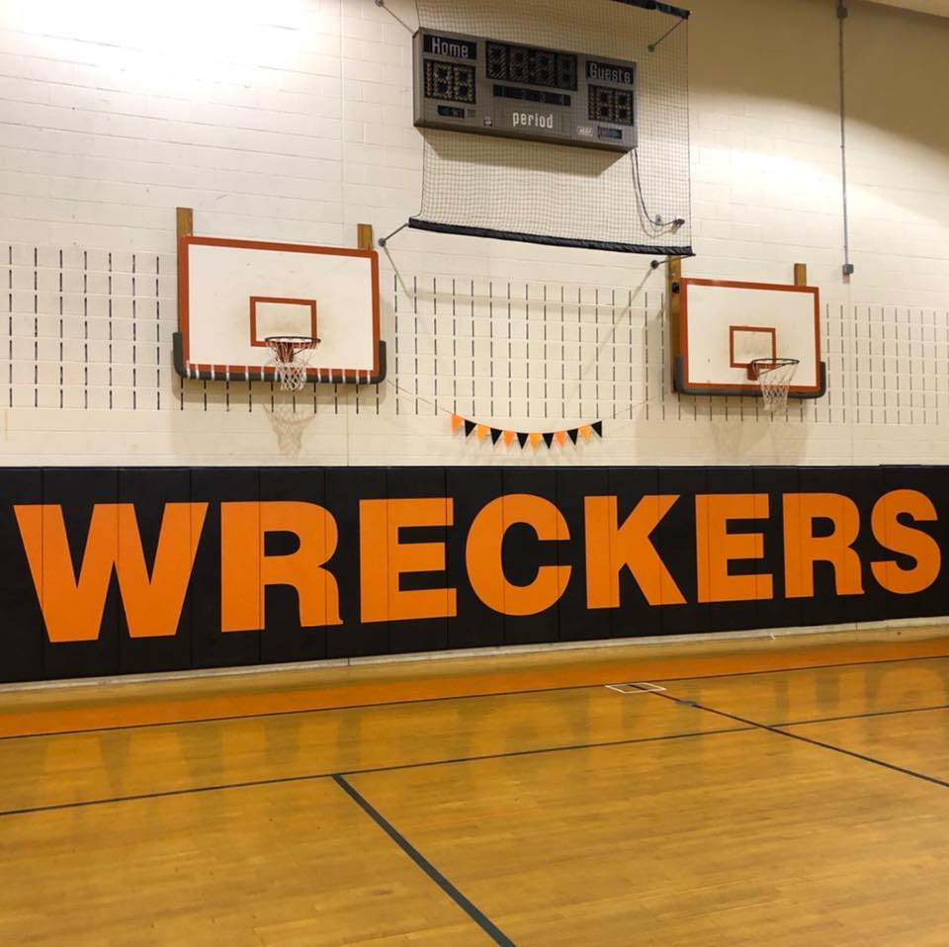

January – December

2024

school resource officer report
Weatherly Area School District

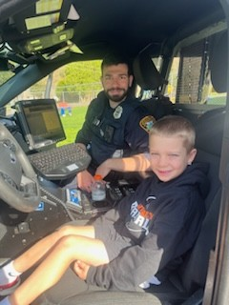

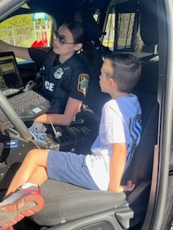 |  |  | mission statement  Weatherly police department  It is our mission to improve the quality of life by providing the highest level of professional police service through a partnership with the community. We are committed to providing a safe, crime free environment by enforcing the laws of the Commonwealth of Pennsylvania and U.S. Constitution. We will accomplish this by practicing our core values of integrity, professionalism and respect.
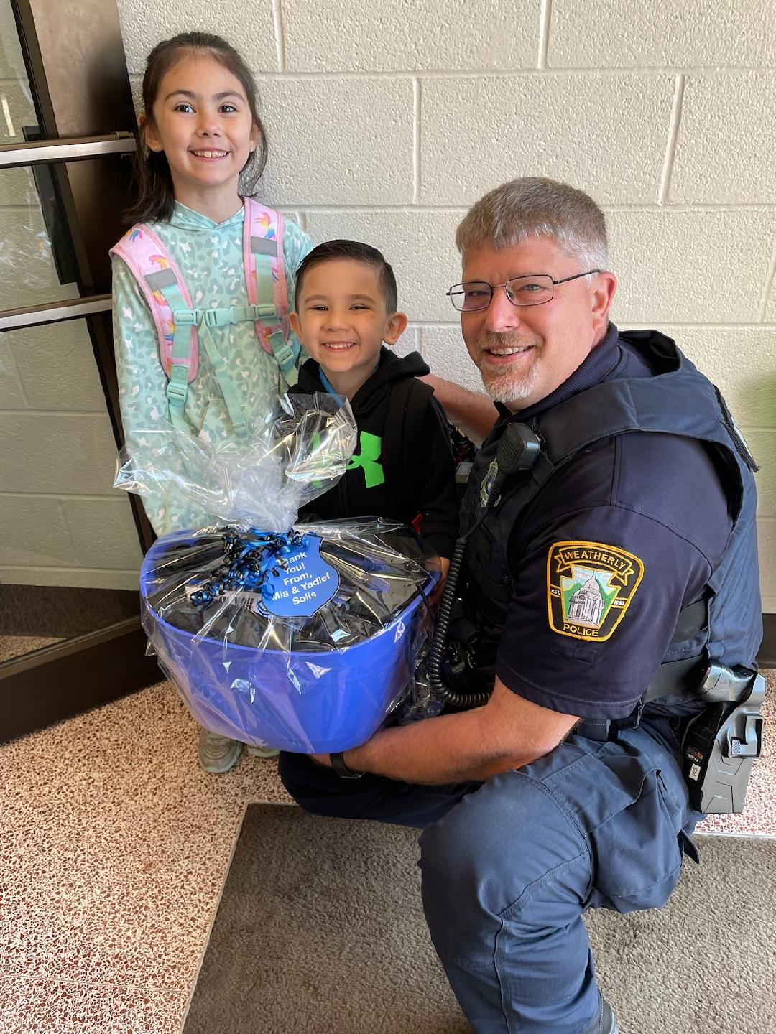

Integrity
The quality of being honest and having strong moral principle: moral uprightness.

professionalism
The competence or skill expected from a professional.

respect
Due regard for the feelings, wishes, rights or traditions of others.

  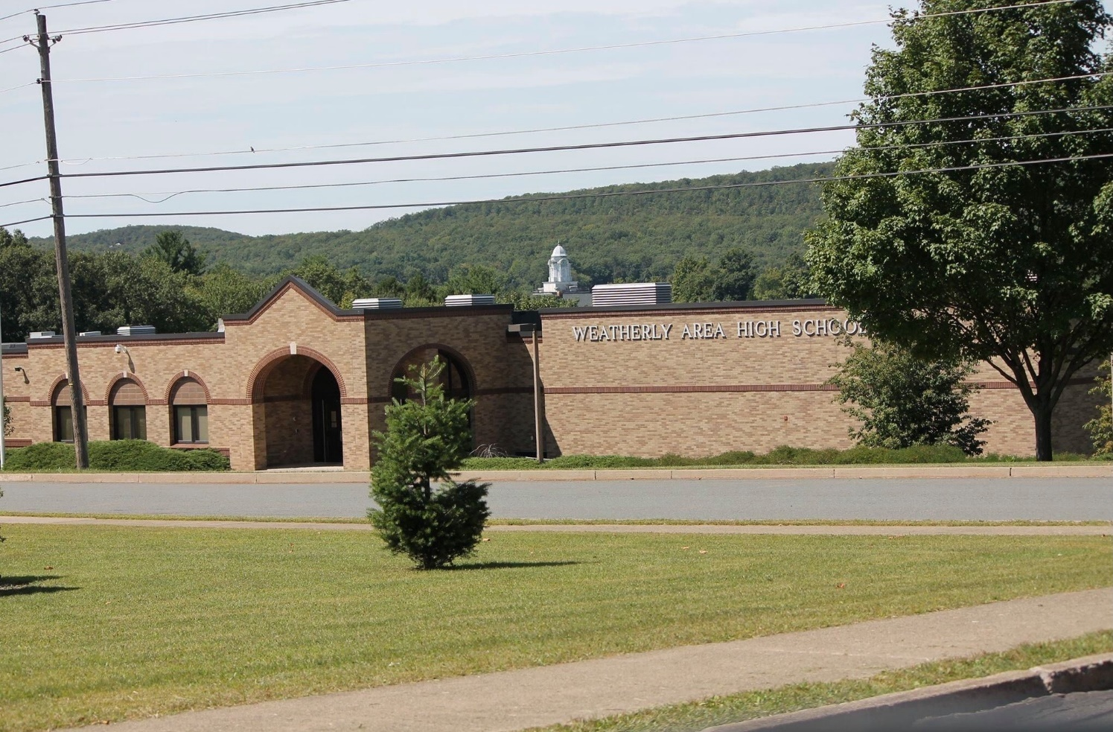 |  |  | SRO  school resource officers  The Weatherly Police Department School Resource Officers strives to keep both students and faculty of the Weatherly School District safe  as they go about their busy academic filled days.  The SRO is responsible for monitoring camera systems, patrolling the campus as well as interacting with students as they aim to leave a positive impact on them.  The SRO’s also participate in school  sporting events, training classes for students and extracurricular activities.

2024 school year incident reports

Administrative Duties……………………………………………………………………………………………………………3
Administrative-Training Given…………………………………………………………………………………………….15
Animal Complaints………………………………………………………………………………………………………………..3
Assault………………………………………………………………………………………………………………………………….5
Assist Other Agencies……………………………………………………………………………………………………………1
Bomb Threat…………………………………………………………………………………………………………………………1
Burglary-False Alarm…………………………………………………………………………………………………………….1
Criminal Mischief………………………………………………………………………………………………………………….4
Departmental Services-Sentinel………………………………………………………………………………………….22
Disorderly Conduct……………………………………………………………………………………………………………..11
Disturbances…………………………………………………………………………………………………………………………2
Fire Alarms (Founded/Unfounded)……………………………………………………………………………………….3
Fire Misc……………………………………………………………………………………………………………………………….2
Fire Drills………………………………………………………………………………………………………………………………7
Harassment………………………………………………………………………………………………………………………..20
Harassment by Communications…………………………………………………………………………………………..5
Lockouts……………………………………………………………………………………………………………………………….4
Lost and Found Property……………………………………………………………………………………………………….4
Lost/Missing Persons…………………………………………………………………………………………………………….6
Liquor Laws…………………………………………………………………………………………………………………………..1
Medical Emergency………………………………………………………………………………………………………………3

Mental Health……………………………………………………………………………………………………………………….4
Narcotics………………………………………………………………………………………………………………………………4
Non-Criminal- Suspicious Persons/Autos………………………………………………………………………………9
Open Doors/Windows…………………………………………………………………………………………………………16
Offenses Against Family/Children…………………………………………………………………………………………5
Parking Violations…………………………………………………………………………………………………………………1
Police Info/Notifications……………………………………………………………………………………………………….5
Pornography/Obscene Material……………………………………………………………………………………………4
Protective Orders………………………………………………………………………………………………………………….1
Public Service………………………………………………………………………………………………………………………..3
Rape……………………………………………………………………………………………………………………………………..3
Sentinel Duties……………………………………………………………………………………………………………………26
Service Calls-Alarms………………………………………………………………………………………………………………3
Sexual Assault……………………………………………………………………………………………………………………….4
Sexual Offenses…………………………………………………………………………………………………………………….3
SRO Assist…………………………………………………………………………………………………………………………488
Suspicious Persons, Autos, Circumstances……………………………………………………………………………5
Training Given…………………………………………………………………………………………………………………….14
Traffic Enforcement…………………………………………………………………………………………………………….33
Traffic Enforcement Complaint…………………………………………………………………………………………….5

Traffic Related Escorts…………………………………………………………………………………………………………..2
Traffic Related Motorists Aid………………………………………………………………………………………………..3
Traffic Offenses…………………………………………………………………………………………………………………..12
Trespassing…………………………………………………………………………………………………………………………..3
Threats (Kill, Bomb, Phone, etc.)……………………………………………………………………………………………7
Truancy…………………………………………………………………………………………………………………………………1
Use of Tobacco/Vape………………………………………………………………………………………………………….15
Weapons………………………………………………………………………………………………………………………………2
Welfare Check………………………………………………………………………………………………………………………6

conclusion

commitment to safety
I The Borough of Weatherly and the Weatherly Area School District agree that it has been and that it shall
Continue to be the primary mission of the Weatherly Borough Police Department and the Weatherly
Area School District School Resource Officers Program to provide a cooperative and united effort to prevent
Crime, disorder, drug activity, gang activity and violence in and around the schools of Weatherly.

We shall reach this goal and fulfill ou rmission through education, awareness, enforcement, innovation, open
Communication and cooperation between all parties.

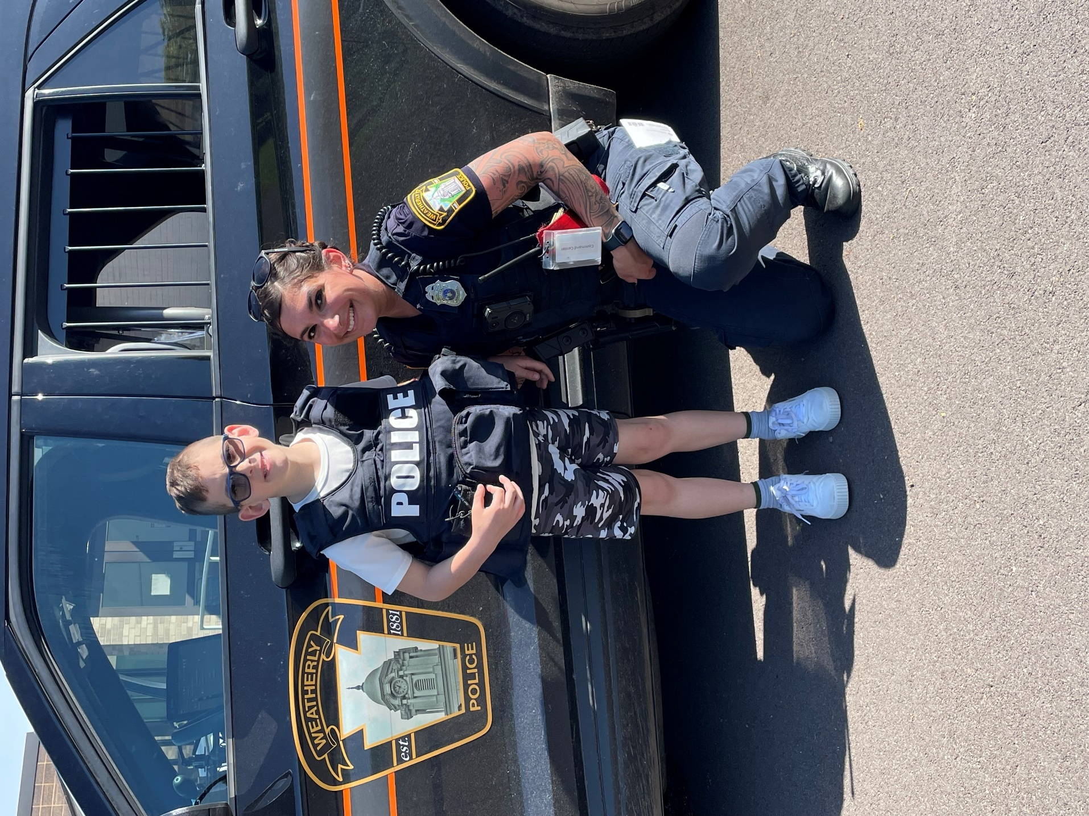



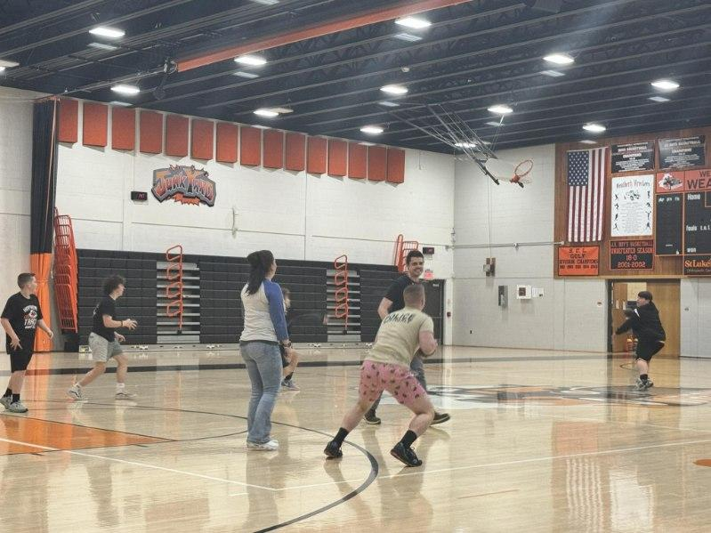



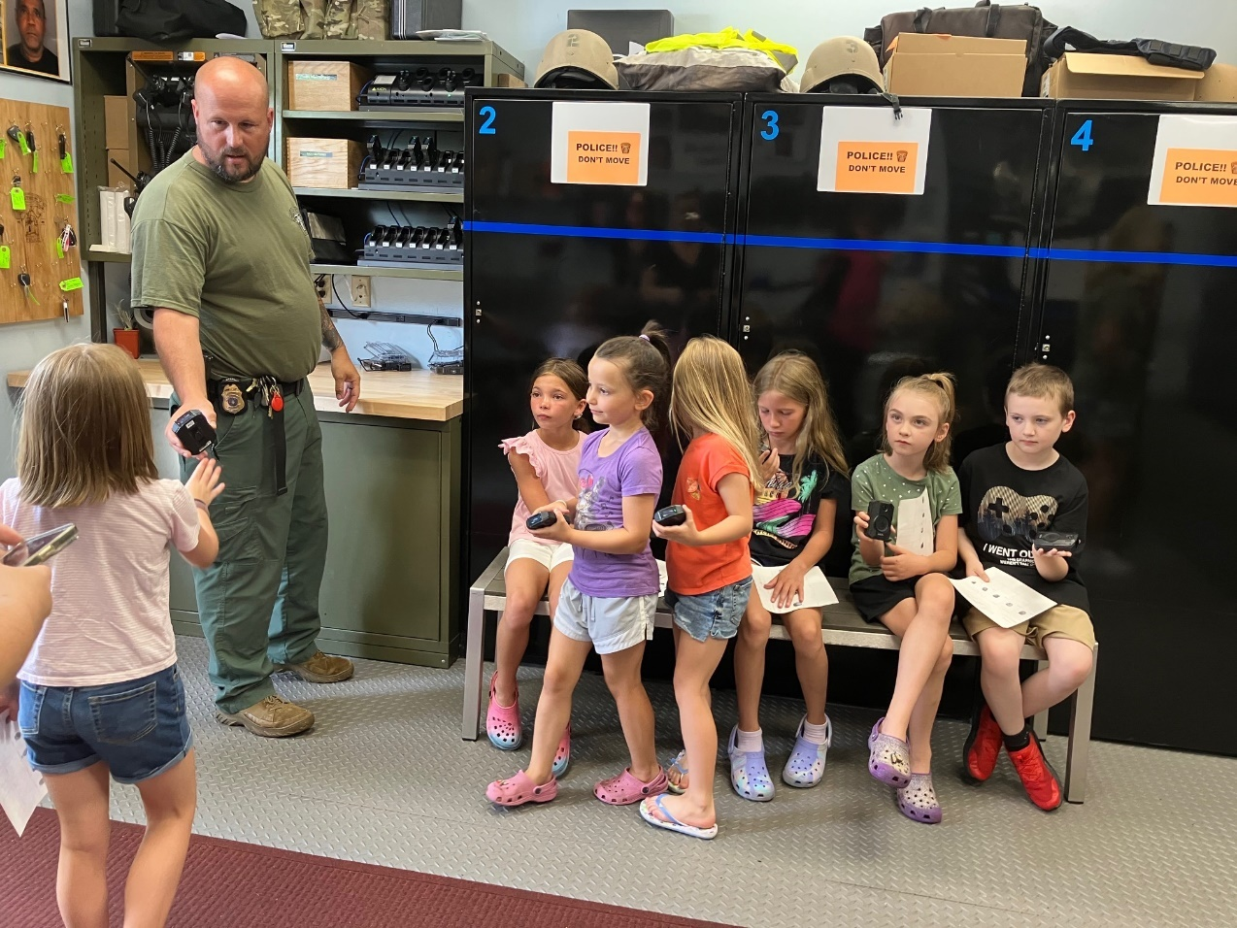
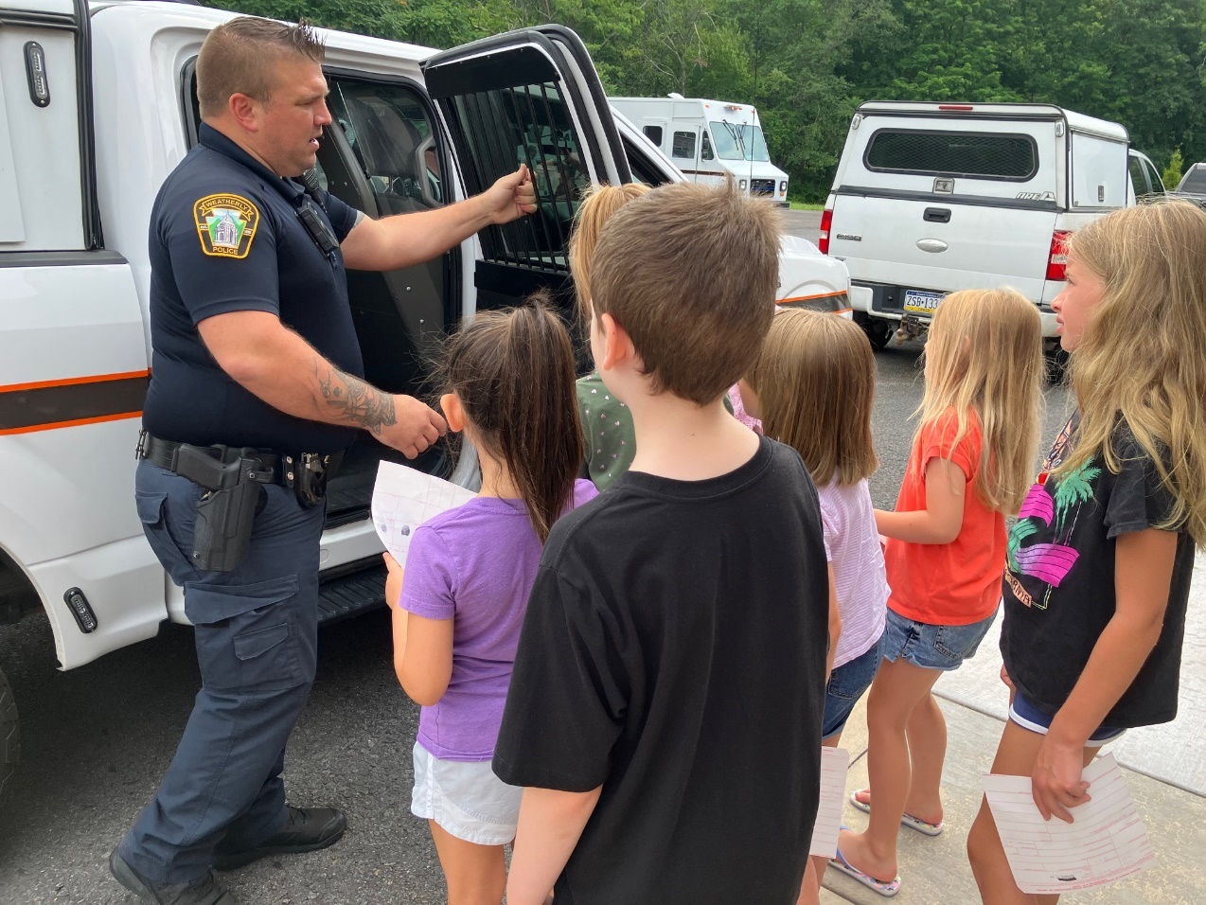
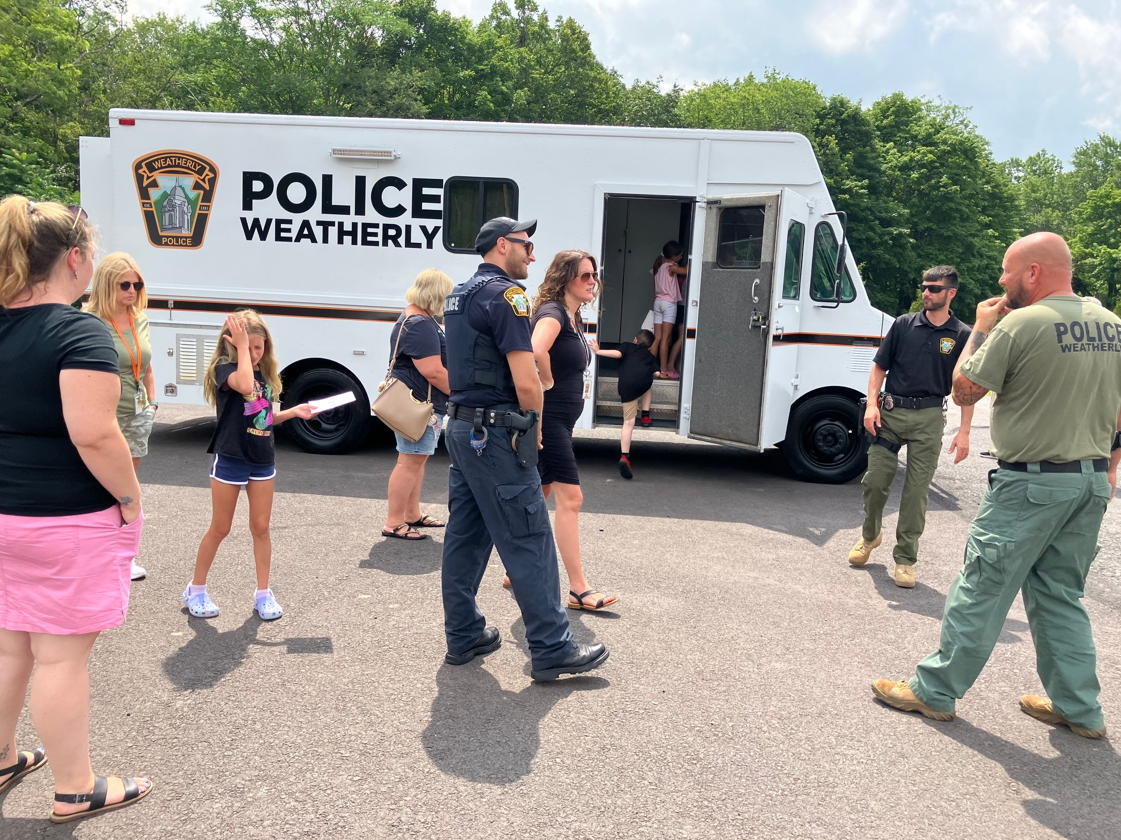

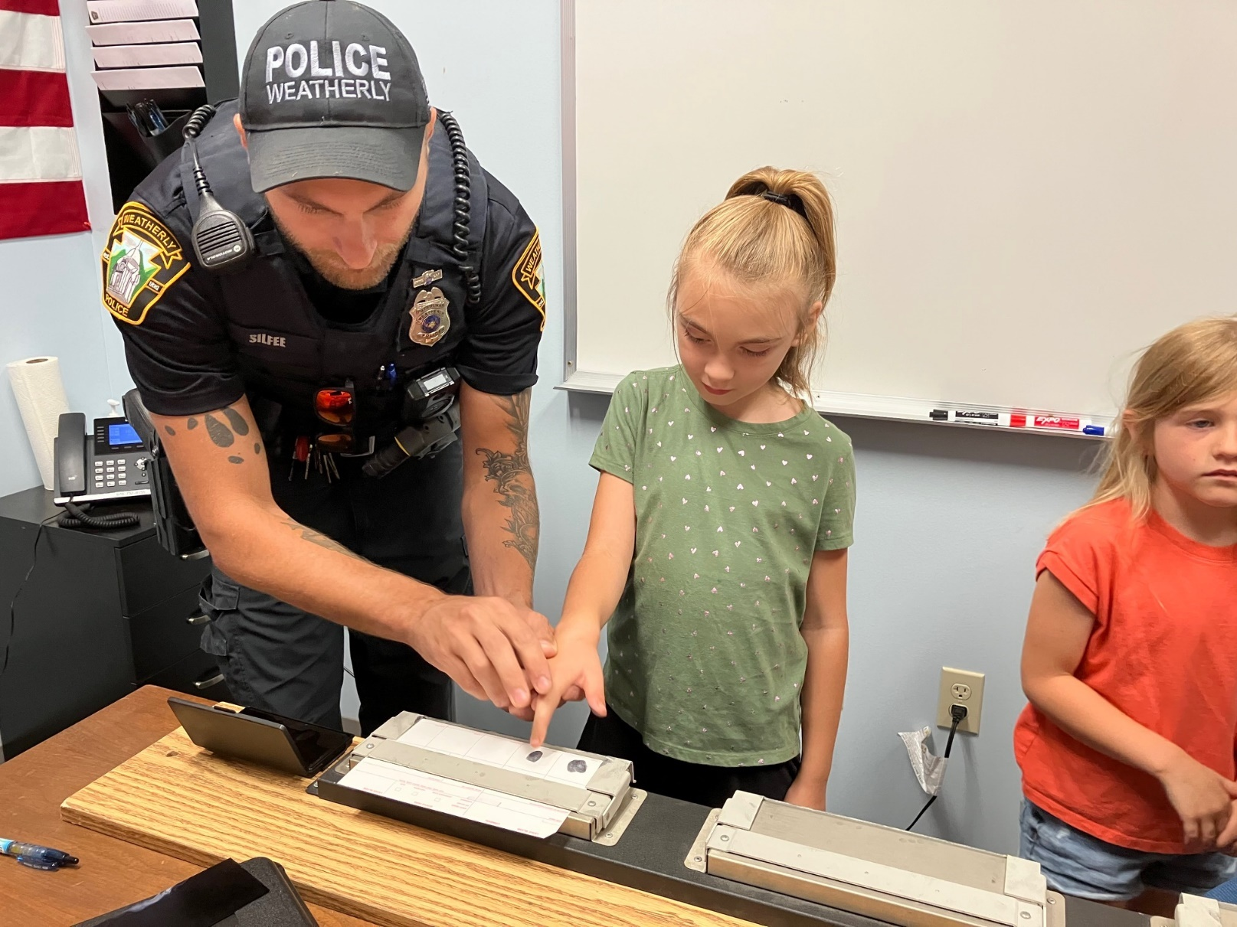

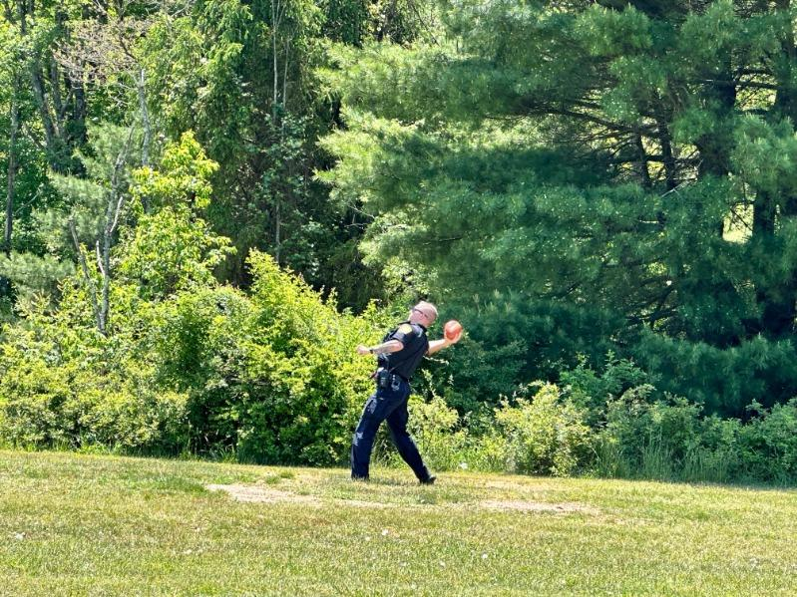
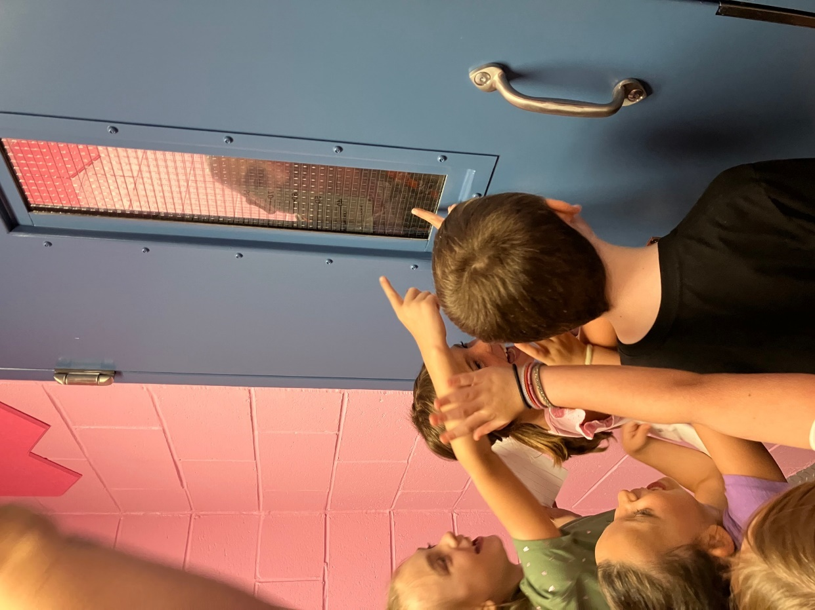

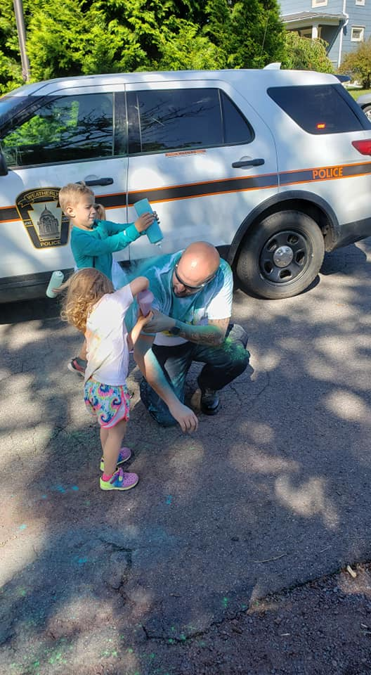

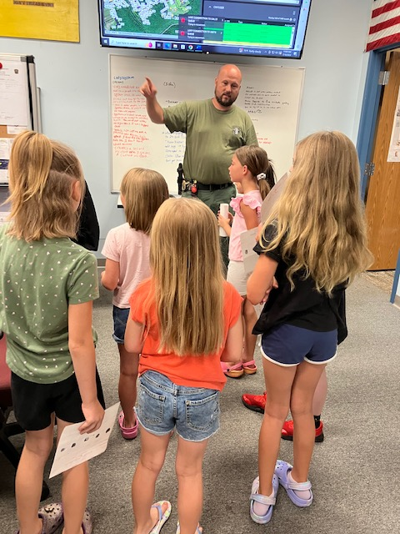
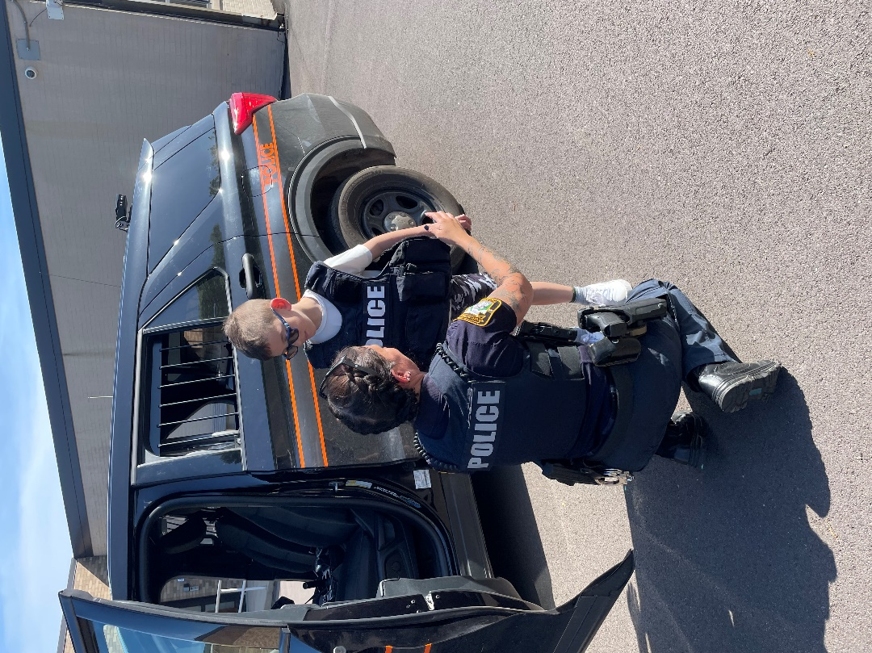

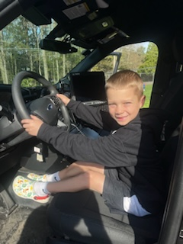
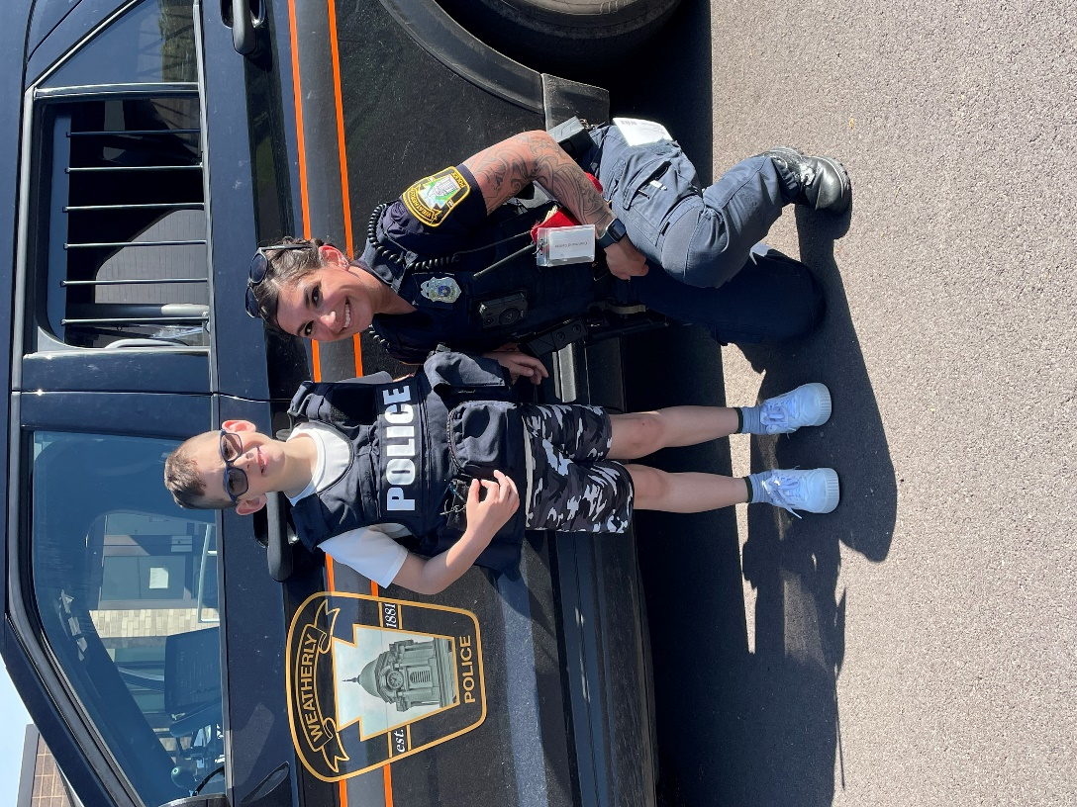

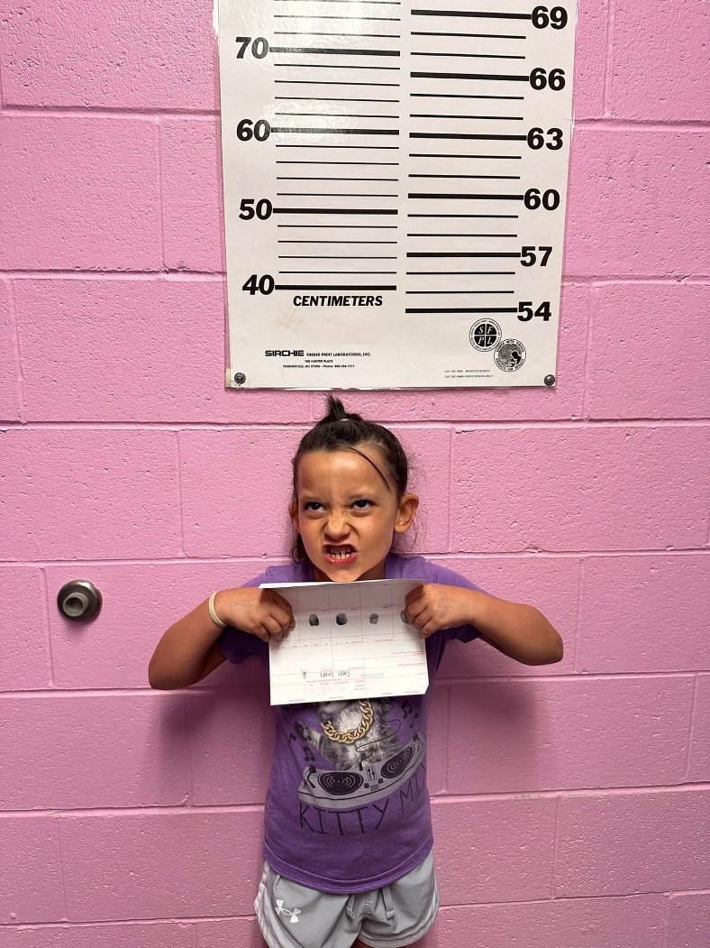
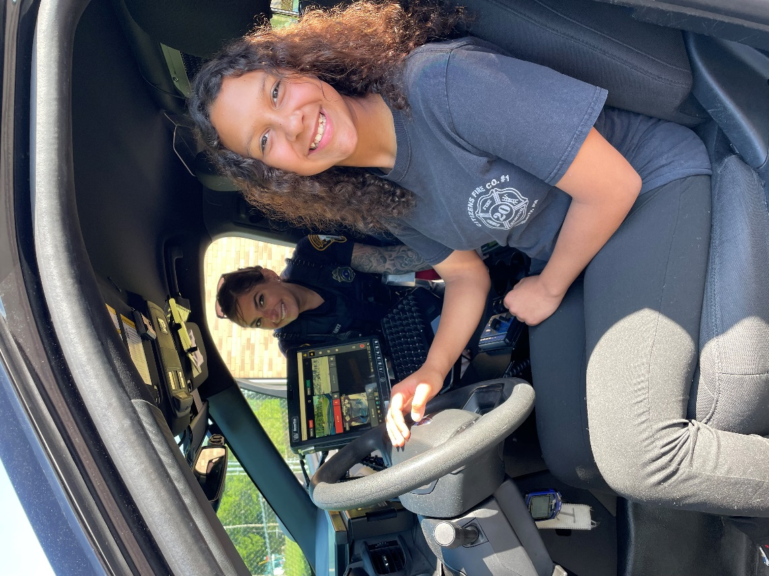
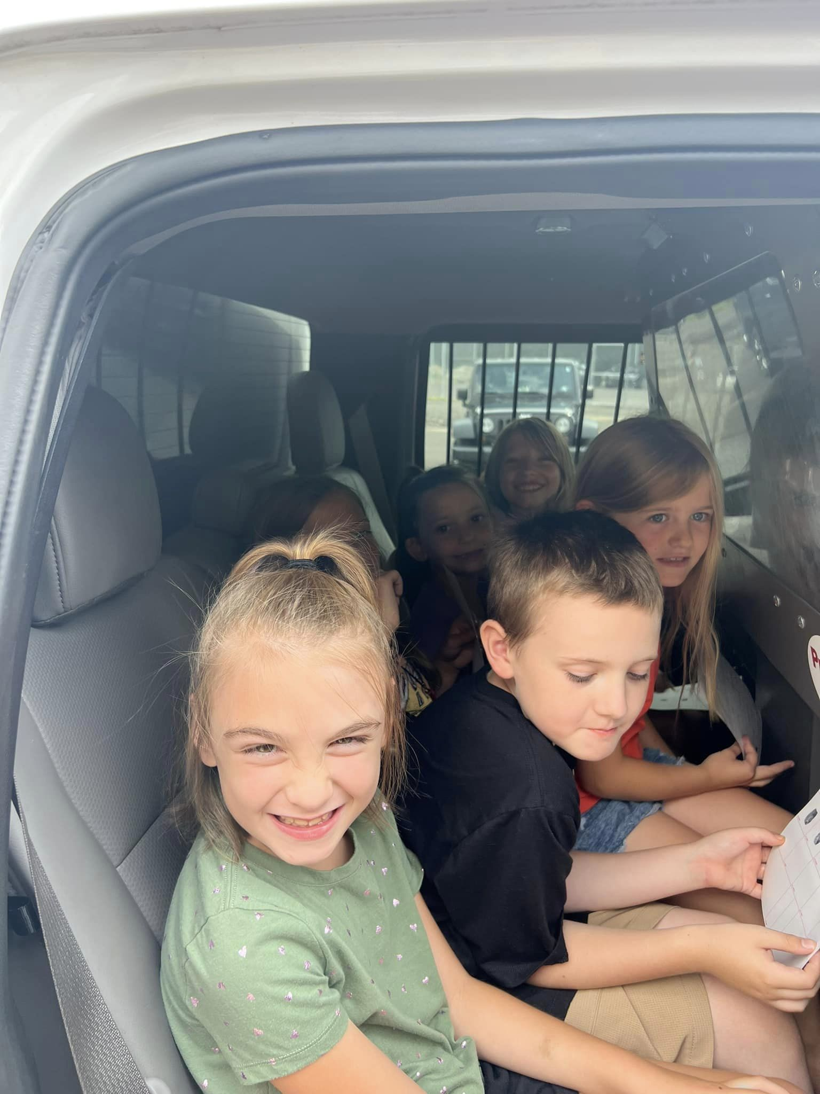

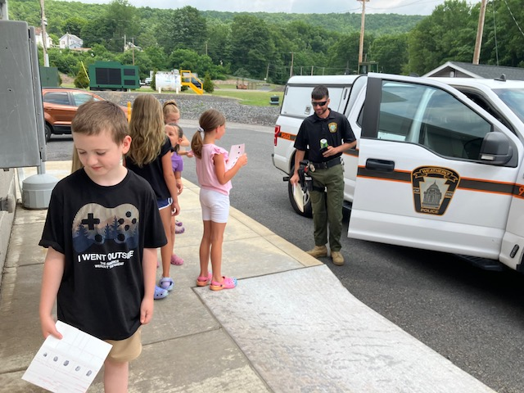
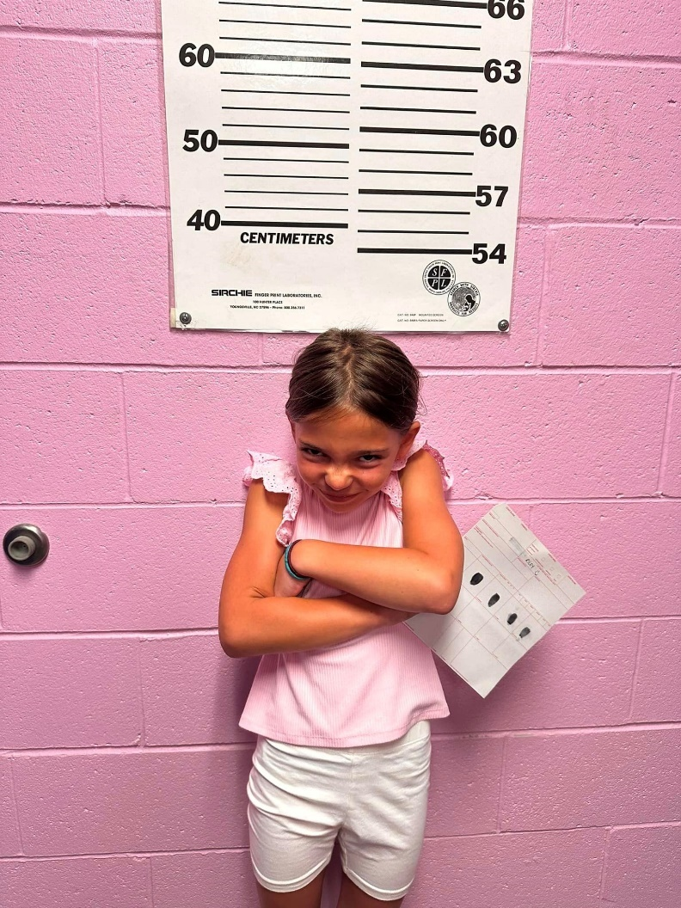

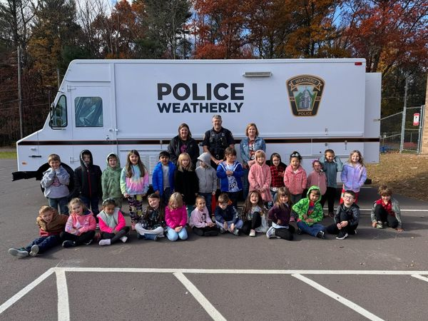



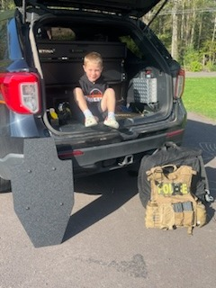
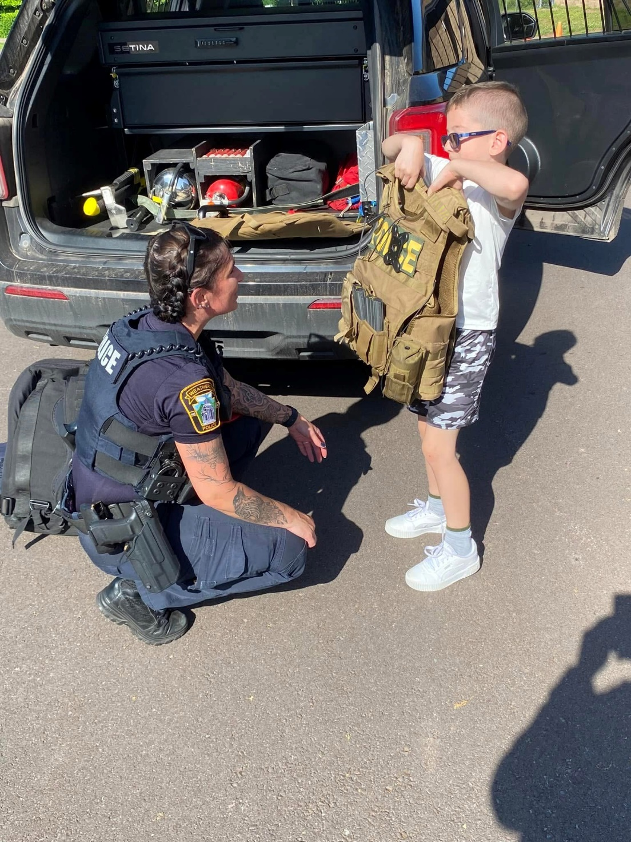

Weatherly Borough Police Department
65 West Main Street
Weatherly, PA 18255
570-427-4241
www.weatherlypd.com

