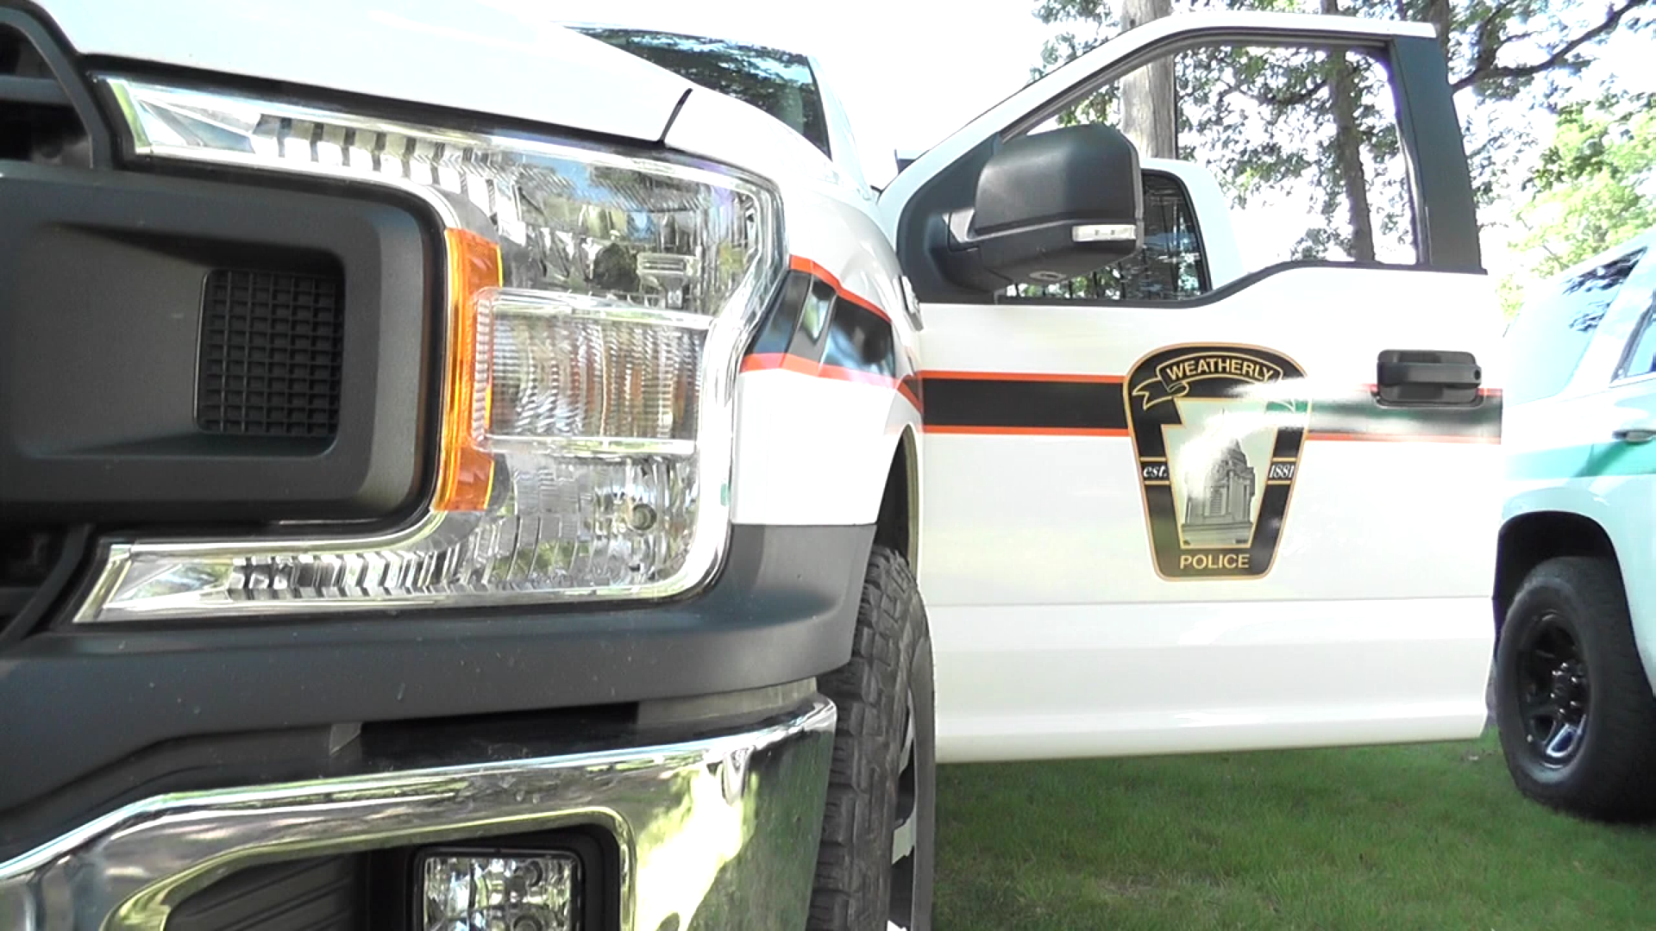

Weatherly Borough Police Department

2022 Report

Phone: 570-427-4241
Emergency: Dial 911

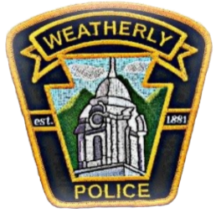
Weatherly Borough Police Department
65 West Main Street
Weatherly, PA. 18255
www.weatherlypd.com

Table of Contents

Message From the Chief…………………………………………………………………..3

Mission Statement………………………………………………………………………….4

Weatherly Overview………………………………………………………………………..5

Police Department Roster……………………………………………….........................6

Fleet Information………………………………………………………….........................8

School Zone Safety………………………………………………………………………...9

Public Information………………………………………………………………………….10

Assisting Other Law Enforcement………………………………………………………..11

Part I Offenses……………………………………………………………………………...13

Part II Offenses……………………………………………………………………………..14

All Calls for Service………………………………………………………………………...15

Traffic Warnings…………………………………………………………......................... 16

Traffic Citations……………………………………………………………………………..17

Non-Traffic Citations……………………………………………………………………….18

Parking Violations……………………………………………………..............................19

Impound Report………………………………………………………..............................20

Vehicle Code Section………………………………………………………………………21

Criminal Arrests……………………………………………………………………………..23

2022 Police Training………………………………………………………………………..24

Community…………………………………………………………………………………...27

Message From the Chief

It is on behalf of the Men and Women of the Weatherly Borough Police department that I present the 2022 Year End Report. September 2022 marked the Weatherly Police Departments first full year in our new station. This station provides a safe and secure facility that allows the men and women of the Department to provide the highest quality services to the residents and visitors to the Borough. 2022 continued to be challenging due to Police Staffing Shortages locally as well as nationwide. The department has been able to provide and maintain 24 hour, 365 days of coverage during these trying times. One of our biggest challenges is that we no longer have the reliable backup from neighboring departments that we had in years past. Some of these departments can no longer fill their duty rosters or cover their own areas consistently with 24-hour police protection. This requires the PA state police to pick up the call volume in these jurisdictions. This adds to a timely back up response when they are requested by us.

The Weatherly Police Department and The Weatherly Area School district have renewed their Memorandum of understanding with a fresh look at the school resource officer positions and response to incidents involving School facilities and entities. We as a department and part of the community are always striving to improve our service to the community by implementing the best practices in policing.

The Weatherly Police Department is moving forward with becoming accredited thru the Pennsylvania Law Enforcement Accreditation Commission by close of business 2023.
We are excited to announce that we will once again be hosting the Junior Police Academy that was furloughed due to COVID this upcoming year as well as another attempt to run the Citizens Police Academy sometime in the late summer months.

I can attest that the officers will continue to preserve the peace, reduce fear and enhance the quality of life for residence and visitors in and around Weatherly. Officers Strive to provide ethical and professional police services with vision and integrity thus enhancing trust and respect within the Borough. We welcome your input and invite you to contact us with any questions or concerns.


Sincerely,

Chief Brian Markovchick

Weatherly Borough Police Department

Mission Statement

It is our mission to improve the quality of life by providing the highest level of professional police service through a partnership with the community. We are committed to creating a safe, crime free environment by enforcing the laws of the commonwealth of Pennsylvania and the U.S. Constitution. We will accomplish this by practicing our core values of integrity, professionalism and respect.

Integrity

The quality of being honest and having strong moral principles; moral uprightness.

Professionalism

The competence or skill expected of a professional.

Respect

Due regard for the feelings, wishes, rights or traditions of others.
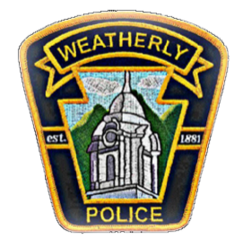
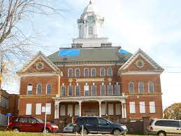
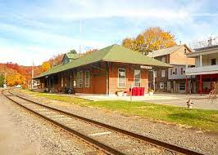
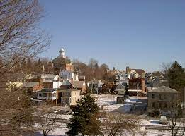

The Borough of

Overview: Borough of Weatherly

Weatherly is located in Carbon County Pennsylvania with an approximate population of 2,600 residents. Weatherly is just 8 miles southeast of Hazleton, 12 miles northwest of Jim Thorpe and 28 miles south of Wilkes-Barre. Weatherly is situated at an elevation of 1,100 feet in the Ridge and Valley Province of the Appalachian Mountains between Spring Mountain and Round Head Mountain to the north, and Broad Mountain to the south.

Weatherly was founded by Benjamin Romig in 1825 through the purchase of a 400-acre piece of land. The Borough was then incorporated on October 8th, 1863. Starting with the timbering industry and moving forward with the development of the railroad and transportation of coal, the population of the town grew dramatically.

Throughout the years, Weatherly remains a rural community of people that love their legacy, cherish the wholesome lifestyle and bask in the beauty of their natural surroundings.

Department Allocations:

4 Full-time Officers

7 Part-time Officers

Police Department Roster

Police Chief Brian Markovchick Sergeant Michael Bogart
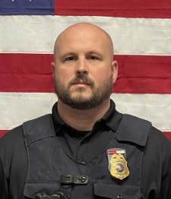
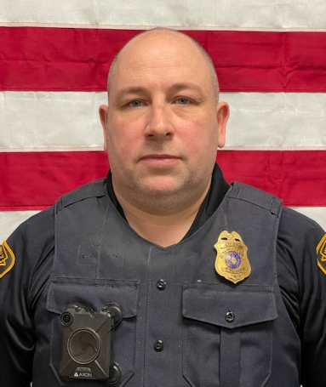

Officer Edward Kubert Officer Joshua Silfee
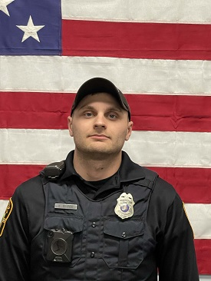
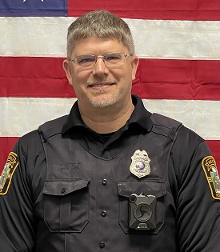

Officer Ashley Harris Officer Sofia Hantz
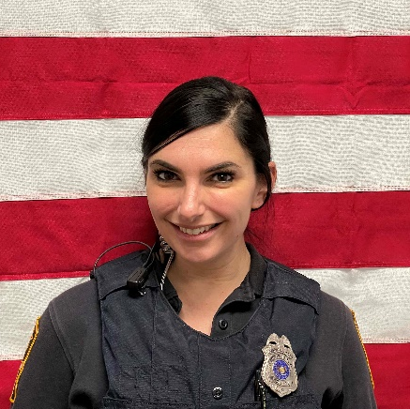
Officer Michael Eyer Officer Zach Wargula

Officer Jon Yaskiewicz Officer John Molosky

Officer Jenny Hoffman
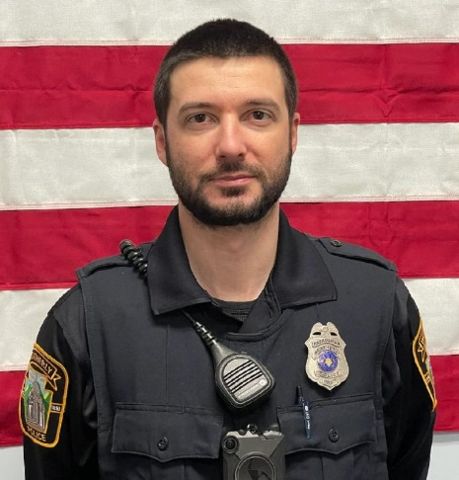
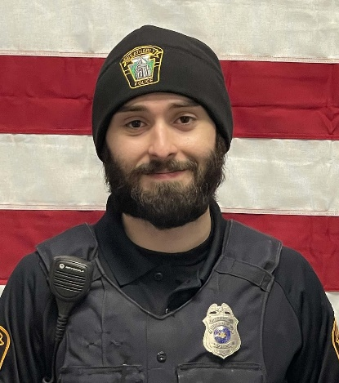

Police Department Fleet

The Weatherly Police Department currently maintains a fleet of Ford and Dodge police vehicles. The department has several fully marked units for patrol operations. The department also has unmarked vehicles that are utilized for patrol and special operations. The department also secured a fully operational crimes scene unit as well as all-terrain vehicles for specialized needs of the department.

All vehicles utilized for patrol are equipped for the everyday tasks to protect not only the citizens of Weatherly but the surrounding communities when assistance is requested. The vehicles are equipped with computers, video/audio recording devices, radios, medical and trauma supplies, fire suppression equipment, patrol rifles, shot guns and spike strips.
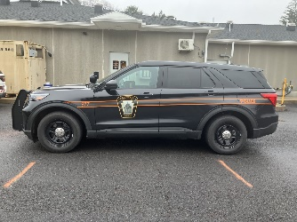

Fleet Inventory:

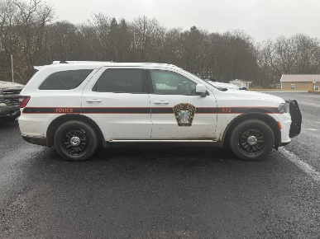
- Marked Patrol Unit 971: 2016 Ford Interceptor
- Marked Patrol Unit 972: 2022 Dodge Durango
- Unmarked Patrol Unit 973: 2010 Ford F-150
- Marked Patrol Unit 974: Mobile Crime Scene Unit
- Marked Patrol Unit 975: 2020 Ford F-150
- Marked Patrol Unit 977: 2022 Ford Interceptor
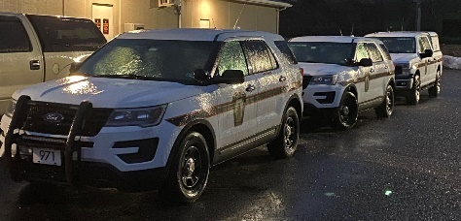
School Zone Safety
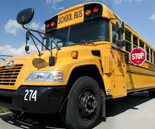
Weatherly has three schools in the borough making
up the Weatherly Area School District. The District is a
public school district in Carbon County Pennsylvania.
It is centered in Weatherly and also serves the Borough
of East Side plus Lehigh, Packer, Lausanne and northern
Kidder Townships.

The district features one elementary, one middle school
and one high school. Officers provide routine patrol
throughout the school day and targeted enforcement
of both pedestrian and vehicular traffic during the
arrival and dismissal of students each day.

The officers also provide periodic school checks which
include a walk-through of the schools, checking in with
faculty and staff and making sure doors are secured.
Officers also get to interact with the students in a
positive environment which promotes better
community relations.

Weatherly Police try to leave a positive impact on
students despite unique and increasing challenges
placed on our youth today.

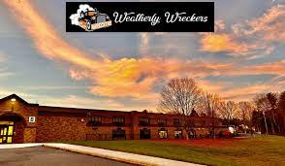

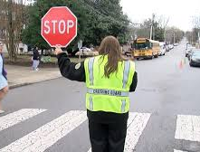

Public Information
Medication Box
The Weatherly Borough Police Department Cabinet for medication drop off is located in the main lobby of the Weatherly Borough building and Police Station. It can be accessed 24 hours a day, 7 days a week, 365 days a year. Pills can be left in original containers or placed in a bag. Please refrain from dropping liquids, saves and creams in the box.
Weatherly Borough Police Department collected approximately 98 lbs. of pills, capsules and several boxes of syringes, epi pens lancets and patches in 2022.

Property Checks
When you are planning away time from your home whether it be for vacation or any other reason, the Weatherly Police Department will periodically check your residence and notify you or your designee if any serious problems are discovered. Some things to remember:
- Property checks are offered to Weatherly Borough residents free of charge.
- Property check submissions must have a start and end date specified.
- As call volume allows, Officers will perform periodic inspections of your property while you are away.
Property Checks Include:
- A perimeter check consisting of a physical and/or visual check of all doors and windows.
- Verification of vehicles left on the property.
- Verification of any people found on the property. Should the need arise, we will have the information available to contact you or another responsible party.
- Only portions of the residential property with direct access will be checked by Officers.
- The property check service is NOT a guarantee that the property is safe or that it will not be burglarized nor a guarantee that the property will be checked.
- It is also not a substitute for an alarm system. The service can’t be provided for properties in which someone is staying at the residence.

Assisting Other Law Enforcement Agencies

The Weatherly Borough Police Department is comprised of several men and women who work day in and day out to provide the best services possible to the Borough of Weatherly. The officers also have the same dedication and core values when called upon to provide assistance to their agencies and communities. It is an honor to have such a great working relationship with not only neighboring departments but also neighboring states as well. Weatherly Police Department assists multiple state and federal agencies on a multitude of different calls and incidents. Some of these agencies require types of assistance that only our department can offer such as use of specialized equipment, working as part of a designated task force or use of technology that nobody else in surrounding areas possess like a mobile fingerprint identification device. It is not without the great team work of all agencies that we keep our communities safe!
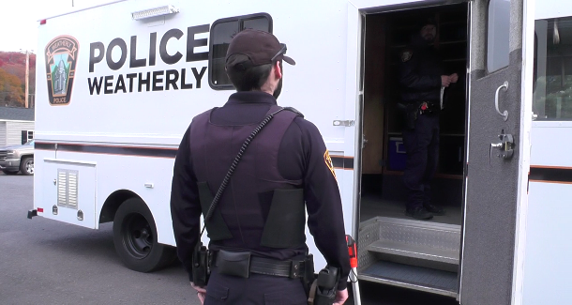
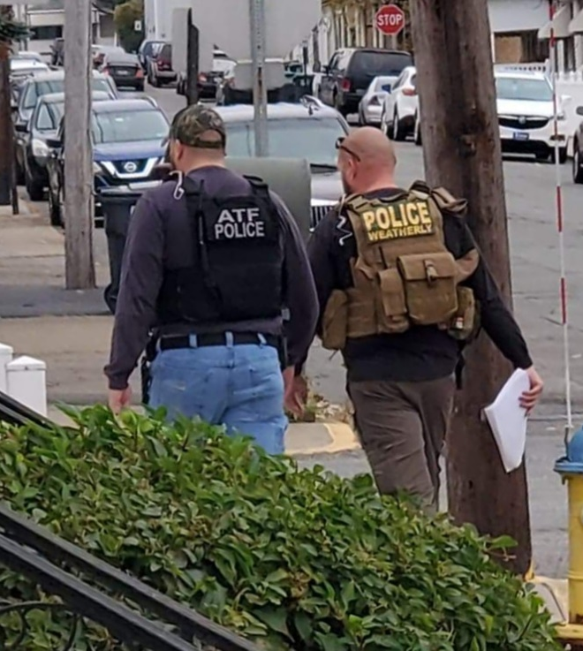

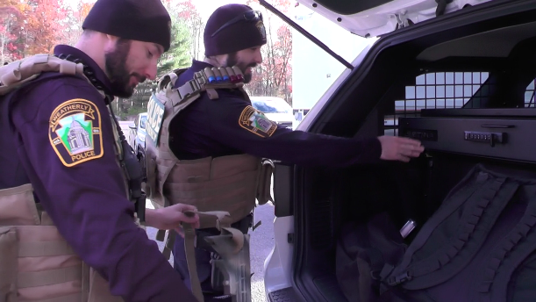

Weatherly Police Department assisted federal, state and local law enforcement a total of 155 calls of assistance

Part I crimes as defined by the FBI are criminal homicide, forcible rape, robbery, aggravated assault, burglary, grand theft auto and arson. The Uniform Crime Reporting reports Part I crimes in terms of both crimes known to police and arrests. Part I crimes are reported in terms of arrests.

Part II crimes as defined by the FBI are forgery, fraud, simple assault, DUI, drug abuse violations, DUI and disorderly conduct. Part II includes, but is not limited to, some victimless crimes.

Weatherly Police Department had a call volume of approximately 3,432 incidents for the year of 2022. These calls and incidents range in severity from traffic warnings to violent crimes and narcotics offenses.

A total of 326 warnings were given for motor vehicle violations
for the year 2022

A total of 290 traffic citations were given for motor vehicle violations
for the year 2022

A total of 57 Non-traffic citations were issued in 2020

A total of 128 Parking Violations were issued in 2022

Impound Report
Weatherly Police Department is unique in that it has its own impound lot which is managed solely by Weatherly Police personnel. A vehicle will be impounded if it was used in the commission of a crime or if it is illegally parked at the time a violation occurs and it is unable to be removed to a location which is legal parking zone, such as the operator not having a valid license.

A total of 63 Vehicles were impounded in 2022

Vehicle Code Section Break Down

1101. Certificate of Title…………………………………………………………………………………………………………………..1
1301. Registration and certificate of title required…………………………………………………………………………50
1332. Display of registration plate……………………………………………………………………………………………………1
1371. Operation following suspension of registration…………………………………………………………………….11
1372. Unauthorized transfer or use of registration…………………………………………………………………………..2
1501. Drivers required to be licensed……………………………………………………………………………………………..53
1543. Driving while operating privilege is suspended or revoked……………………………………………………42
1786. Required financial responsibility……………………………………………………………………………………………11
3111. Obedience to traffic control devices……………………………………………………………………………………….4
3305. Limitations on overtaking on the left………………………………………………………………………………………2
3307. No passing zone………………………………………………………………………………………………………………………2
3308. One-way roadways and rotary traffic islands…………………………………………………………………………..9
3309. Driving on roadways laned for traffic………………………………………………………………………………………1
3323. Stop signs and yield signs……………………………………………………………………………………………………….23
3334. Required position and method of turning………………………………………………………………………………..1
3353. Prohibitions in specified places………………………………………………………………………………………………..6
3354. Prohibited parking……………………………………………………………………………………………………………………1
3360-3369. Speed Restrictions…………………………………………………………………………………………………………83
3505. Riding on roadways and pedal cycle paths………………………………………………………………………………..1
3550. Pedestrians under influence of alcohol or controlled substance……………………………………………….1
3702. Limitations on backing………………………………………………………………………………………………………………1
3717. Trespass by motor vehicle………………………………………………………………………………………………………..2
3736. Reckless driving………………………………………………………………………………………………………………………..1
3744. Duty to give information and render aid…………………………………………………………………………………..1
3745. Accidents involving damage to unattended vehicle or property……………………………………………….2
3809. Restrictions on alcoholic beverages………………………………………………………………………………………….2

4103. Vehicle equipment standards……………………………………………………………………………………………………5
4301-4310. Lighting Equipment………………………………………………………………………………………………………..18
4523. Exhaust system, mufflers and noise control………………………………………………………………………………2
4524. Windshield obstructions and wipers…………………………………………………………………………………………4
4525. Tire equipment and traction surfaces……………………………………………………………………………………….1
4581. Restraint systems………………………………………………………………………………………………………………………5
4703. Operation of vehicle without official certificate of inspection…………………………………………………50
4902. Restrictions on use of highways and bridges…………………………………………………………………………….3
6311. Enforcement authority……………………………………………………………………………………………………………..1
7726. Careless driving of an ATV…………………………………………………………………………………………………………1

Criminal Arrests In 2022

During the course of duty, Weatherly Borough Police Officers regularly arrest and/or place someone in custody. An arrest is the act of apprehending and taking a person into custody usually because the person has been suspected of or observed committing a crime. After being taken into custody, the person can be questioned further and/or charged. An arrest is a procedure in a criminal justice system.
In 2022, Weatherly Police Department arrested approximately 44 offenders. These crimes range in severity from possession of narcotics to violent crime. Approximately 38 offenders were placed in custody in our holding cells located at Weatherly Police Department.
These criminal arrests added up to 202 criminal charges filed.



2022 Officer Training

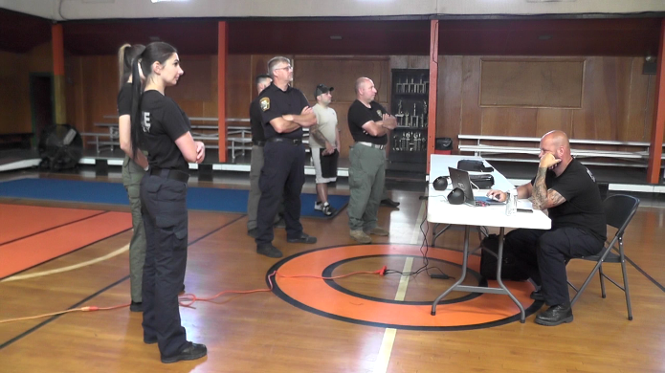
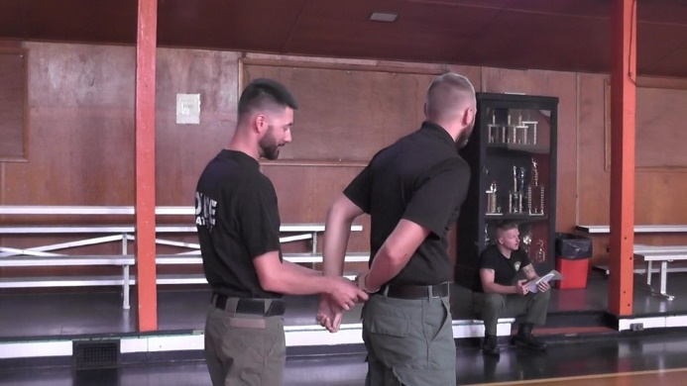
Our officers participate in many law enforcement training updates and classes. All police officers in the commonwealth are required by the Municipal Police Officer’s Educations and Training Commissions (MPOETC) to attend annual legal updates, as well as perform an annual firearms qualification in order to maintain their police officer certifications.

The Weatherly Police Department goes above and beyond the mandatory training requirements established by MPOETC. We are committed to providing our officers with the proper training to carry out their duties effectively and safely. Our commitment to training goes hand in hand with our dedication to provide a professional approach, integrity and respect to anyone we may encounter.

Officer Jonathan Yaskiewicz:
Course: Handgun and shotgun qualification 8 hours
Course: Police rifle qualification 8 hours
Course: MPOF Control tactics

Officer Ashley Harris:
Course: Handgun and shotgun qualification 8 hours
Course: Police rifle qualification 8 hours
Course: Woodland Tactical Ops
Course: Interview and interrogation
Course: MPOF Control tactics

Officer Edward Kubert:
Course: Handgun and shotgun qualification 8 hours
Course: Police rifle qualification 8 hours
Course: Medical marijuana workshop
Course: Heavy equipment
Identification and investigation
Course: MPOF Control tactics

Officer Michael Eyer:
Course: Handgun and shotgun qualification 8 hours
Course: Police rifle qualification 8 hours
Course: MPOF Control tactics

Officer Zachary Wargula:
Course: Handgun and shotgun qualification 8 hours
Course: Police rifle qualification 8 hours
Course: MPOF Control tactics

Officer Joshua Silfee:
Course: Handgun and shotgun qualification 8 hours
Course: Police rifle qualification 8 hours
Course: Basic active shooter Level I
Course: Medical marijuana workshop
Course: Shoe and tire impression evidence
Course: Advanced roadside impaired driving enforcement
Course: Standardized field sobriety testing
Course: Basic crime scene photography course
Course: Fire investigation scene safety
Course: Child abuse investigation
Course: MPOF Control tactics

Officer John Molosky:
Course: Handgun and shotgun qualification 8 hours
Course: Police rifle qualification 8 hours
Course: PA Homicide investigation conference
Course: MPOF Control tactics

Officer Jenny Hoffman
Course: Handgun and shotgun qualification 8 hours
Course: Police rifle qualification 8 hours
Course: MPOF Control tactics

Officer Sofia Hantz:
Course: Handgun and shotgun qualification 8 hours
Course: Police rifle qualification 8 hours
Course: School Resource Officer
Course: Understanding Bias
Course: Use of force
Course: Basic active shooter Level I
Course: Medical marijuana workshop
Course: Woodland Tactical Operations 40 hours
Course: Drug identification
Course: Intro to patrol drug investigation
Course: Interview and interrogation
Course: MPOF Control tactics

Chief Brian Markovchick:
Course: Handgun and shotgun qualification 8 hours
Course: Police rifle qualification 8 hours
Course: Taser re-certification
Course: Post blast investigation ATF 40 hours
Course: Fatal fire investigation 8 hours
Course: MPOF Control tactics

Sergeant Michael Bogart
Course: Handgun and shotgun qualification 8 hours
Course: Police rifle qualification 8 hours
Course: School resource officer 40 hours
First aid instructor
Course: Taser re-certification
Taser instructor
Course: Active attack event response leadership
Course: Basic workforce security awareness
Course: Civilian response to active shooter events
Course: Class A wiretapping and electronic surveillance certification
Course: Active shooter FEMA Training
Course: Post blast investigative techniques course ATF
Course: Federal Law Enforcement mobile device investigation program
Course: MPOF control tactics
In Our Community

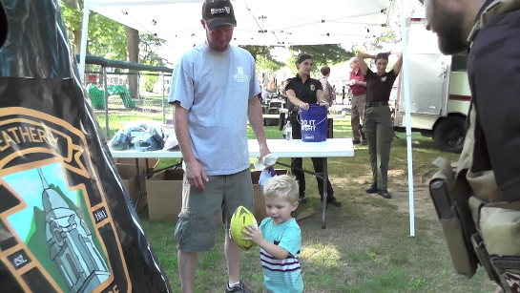
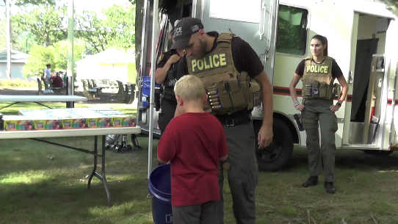
The Weatherly Borough Police Department is committed to serving the community through its mission of practicing the core values of integrity, professionalism and respect. The Officers are committed to fair and impartial enforcement of the laws, crime prevention, furthering and employing the principles of community while keeping the streets safe for both residents and visitors of the Borough.

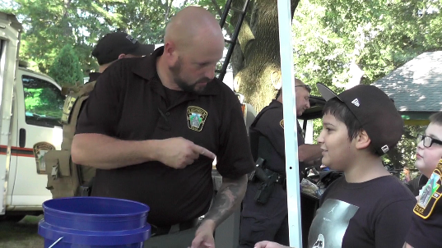
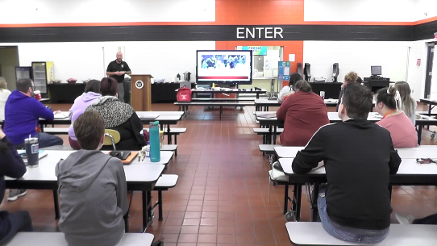
In 2022, many Covid restrictions were lifted allowing the Officers to participate in community events such as National Night Out, the annual Halloween parade and the summer outdoor festival at Eurana park. Officers also hit the basketball court this past fall for fun and games as they faced off with teachers and faculty from the Weatherly Area School District. The Department also partners with organizations like the American Legion and the Weatherly School District to promote healthy activities and events for youth and young adults.

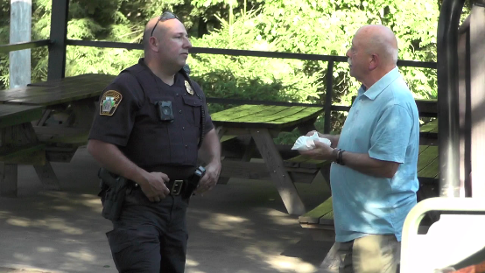
Officers of the borough strive to work hand in hand with members of the community to fight crime and promote a higher quality of life. The Department is located at 65 West Main Street and is open round-the-clock 365 days a year. Residents can stop by the station to file reports, get information on public safety and speak one-on-one with an officer. They can also reach us at 570-427-4241 or visit weatherlypd.com

