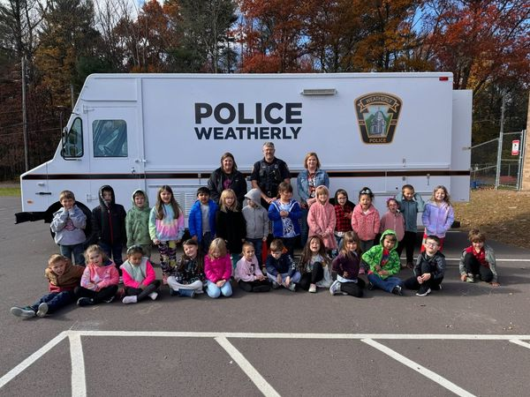

WEATHERLY POLICE

Annual Report
  - 2024

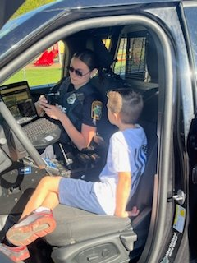 | Message From the Chief 3  Mission Statement 4  Weatherly Overview 5  Police Roster 6  Police Fleet 8  School Resource Officers 9  School Year Incident Reports 10  Public Information 12  Assisting Other Agencies 13  Calls For Service 14  Part I Offenses 15  Part II Offenses………………………………..16  Traffic Warnings……………………………….17  Traffic Citations………………………………..18  Parking Violations……………………………..19  Vehicle Code Section Breakdown…………..20  Impound Report……………………………….22  Non-Traffic Citations………………………….23  Criminal Arrest………………………………...24  Officer Training………………………………..27  Notable News………………………………….30  Community Outreach…………………………33
  TABLE OF CONTENTS

Message from the chief
I am proud to present the Weatherly Borough Police Department 2024 annual report. The report highlights our dedication to excellence and our continuous commitment to provide effective, efficient and responsive police services to the citizens of Weatherly Borough.

2024 had some changes and growth for the department. We have started to upgrade our reports management system with a new “CODY” system which is replacing the antiquated system which the department has used since 1991. The department has reduced its manpower with one full-time officer leaving the department and the loss of one marked patrol unit. We have upgraded 80% of our radios to new units which are once again compatible with surrounding agencies in Luzerne and Schuylkill counties.

We will continue to work with our local stakeholders and other law enforcement partners to enact sound and innovative strategies to address safety and crime concerns within the Borough. Myself and the officers are grateful for the support our department receives from our residents.

It is humbling to work with dedicated and professional officers who serve and protect the residents and visitors of Weatherly Borough. This report will show the excellence, innovation and dedication to providing effective and responsive police service while maintaining respect for all. Thank you for taking the time to review our report.

Chief Brian Markovchick
Weatherly Borough Police Department


mission statement

It is our mission to provide the quality of life by providing the highest level of professional police service through a partnership with the community. We are committed to creating a safe, crime free environment by enforcing the laws of the Commonwealth of Pennsylvania and the U.S. Constitution. We will accomplish this by practicing our core values of integrity, professionalism and respect.

- Integrity: The quality of being honest and having strong moral principle; moral uprightness
- Professionalism: The competence and skill expected of a professional
- Respect: Due Regards for feelings, wishes, rights or traditions of others
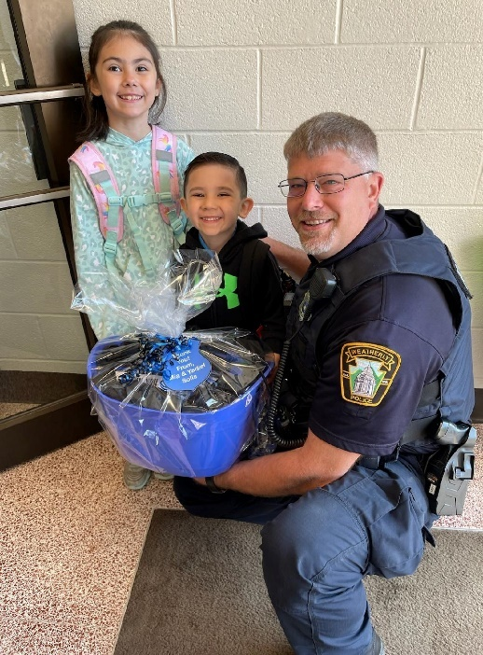
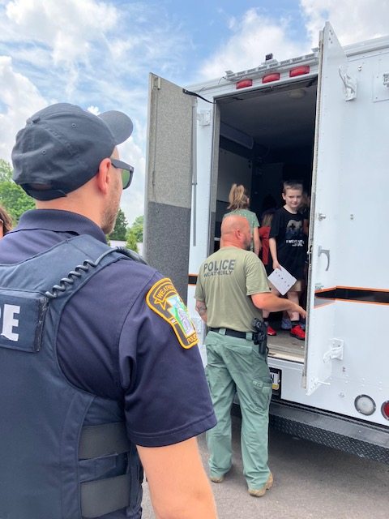

weatherly overview

The Borough of Weatherly is located in Carbon County with a population of approximately 2,900 residents. The quaint community is nestled in the mountains of northeast Pennsylvania and is conveniently located to neighboring towns which include Hazleton, Beaver Meadows, Jim Thorpe and Wilkes-Barre.
History of the Borough
Weatherly was founded in 1825 by Benjamin Romig through the purchase of a 400-acre piece of land. The Borough was then incorporated on October 8th, 1863. The Borough began as a haven from the timbering industry and proceeded to expand with the development of the railroad and transportation of coal.
The Borough is situated at an elevation of 1,100 feet in the Ridge and Valley Province of the Appalachian Mountains between Spring Mountain and Round Head Mountain to the north and Broad Mountain to the south.
Weatherly is home to Eurana and Tweedle Parks where residents can enjoy the great outdoors in a peaceful setting during all four seasons. The borough is currently working on a trail project that once completed, will connect to the D and L trail in Jim Thorpe. The borough is also home to many mom-and-pop businesses giving it a down-home feel. It’s a small borough where residents can take pride in their community and strive to keep it safe and sound.
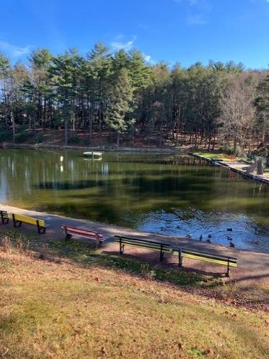
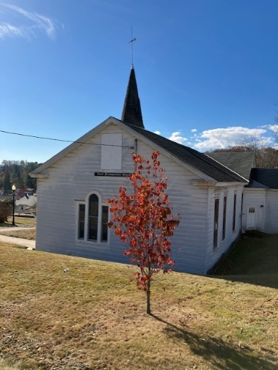
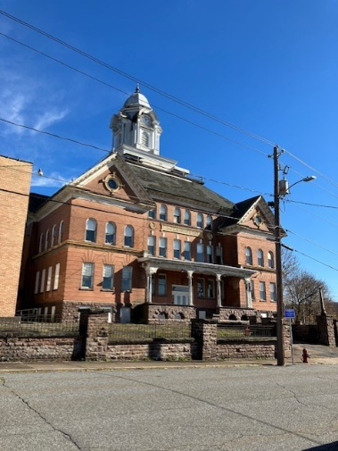

police department roster







Chief Brian Markovchick Sergeant Michael Bogart

Officer Edward Kubert Officer Michael Eyer Officer Ashley Harris





Officer Joshua Silfee Officer Sofia Hantz Officer Christopher Belles




Officer Nicola Palermo Officer Jon Yaskiewicz Officer John Molosky

POLICE DEpaRTMENT FLEET

The Weatherly Police Department currently has a fleet of Ford and Dodge police vehicles. The fleet includes both marked and unmarked vehicles that are utilized for patrol as well as special operations. The fleet also features a fully operational crime scene unit along with all-terrain vehicles for specialized needs of the department.
All vehicles are equipped with computers, radios, video/audio recording devices, patrol rifles, shot guns, spike strips and medical/trauma supplies for medical emergencies.
- Marked Patrol Unit 972: 2022 Dodge Durango
- Unmarked Patrol Unit 973: 2010 Ford F-150
- Marked Patrol Unit 974: Mobile Crime Scene Unit
- Marked Patrol Unit 975: 2020 Ford F-150
- Marked Patrol Unit 977: 2022 Ford Interceptor
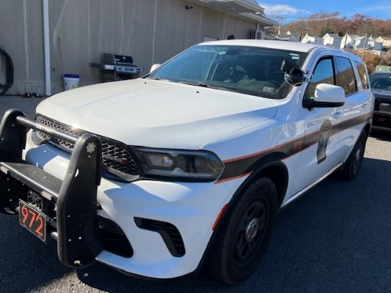

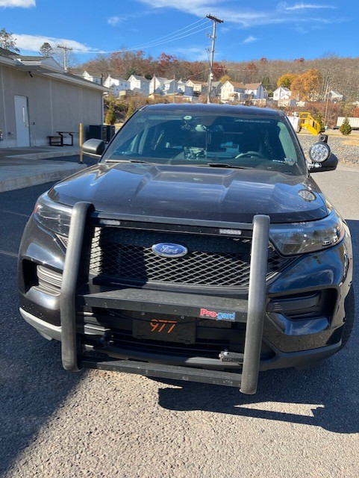

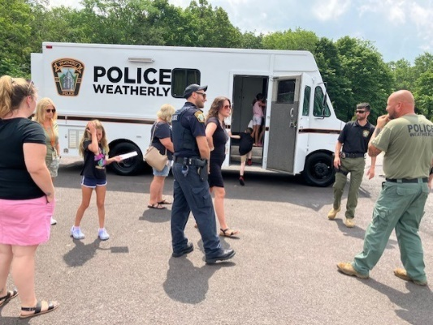

school resource officers

The School Resource Officer Program was implemented in the Weatherly Area School District in November 2022 by mutual consent and agreement between the Borough of Weatherly and the Weatherly Area School District.
Both parties agreed that it has been and shall continue to be the primary mission of the Weatherly Borough Police Department and the Weatherly Area School District School Officers Resource Program to provide a united and cooperative effort to prevent crime, disorder, drug activity, gang activity and violence in and around the schools of Weatherly. We shall reach this goal and fulfill our mission through education, awareness, enforcement, innovation, open communication and cooperation between all parties.
The School Resource Officers Program Command Center is located in the Weatherly Area Elementary/Middle School. The Command Center is home to advanced equipment which allows the Officers to better look out for the safety of both students and staff.

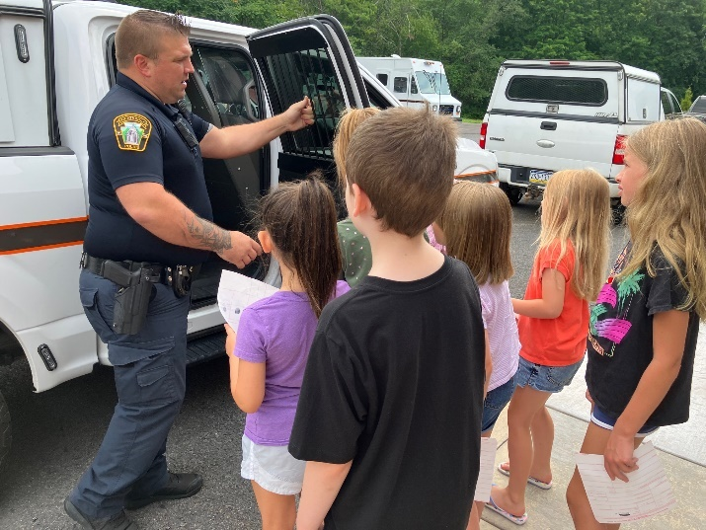


2024 SCHOOL YEAR INCIDENT REPORT
INCIDENTS |  |  |  | TOTAL
Assist Other Agencies |  |  |  | 1
Administration – Training Given |  |  |  | 15
Administrative Duties |  |  |  | 3
Assault |  |  |  | 5
Bomb Threat |  |  |  | 1
Burglary-False Alarm |  |  |  | 1
Criminal Mischief |  |  |  | 4
Disorderly Conduct |  |  |  | 11
Disturbances - Juvenile |  |  |  | 2
Departmental Services - Sentinel |  |  |  | 22
Fire Alarms (Founded/Unfounded) |  |  |  | 3
Fire Drills |  |  |  | 7
Fingerprinting |  |  |  | 0
Harassment |  |  |  | 20
Harassment by Communications |  |  |  | 5
Lockouts |  |  |  | 4
Lost and Found Property |  |  |  | 4
Lost/Missing Persons |  |  |  | 6
Medical Emergency |  |  |  | 3
Mental Health |  |  |  | 4
Narcotics |  |  |  | 4
Non-Criminal: Suspicious Persons/Autos |  |  |  | 9
Non-Criminal: Water Leaks, Mains, etc. |  |  |  | 0
Open Doors/Windows - Discovered |  |  |  | 16
Offenses Against Family/Children |  |  |  | 5
Parking Violations |  |  |  | 1
Police Info & Notifications |  |  |  | 5
Pornography/Obscene Materials |  |  |  | 4
Protective Orders |  |  |  | 1
Public Service |  |  |  | 3
SRO Assist |  |  |  | 488
Rape |  |  |  | 3
Suspicious Persons, Auto, Circumstances |  |  |  | 5
Service Calls - Alarms |  |  |  | 3
Sex Offenses |  |  |  | 3
Threats (Kill, Bomb, Phone, etc.) |  |  |  | 7
Truancy |  |  |  | 1
Traffic Enforcement - Complaint |  |  |  | 5
Traffic Related Escorts |  |  |  | 2
Traffic Related – Motorists Aid |  |  |  | 3
Traffic Accidents |  |  |  | 0
Traffic Enforcement |  |  |  | 33
Trespassing |  |  |  | 3
Use of Vape/Tobacco |  |  |  | 15
Weapons |  |  |  | 2
Welfare Check |  |  |  | 6

PUBLIC INFORMATION
Residents who live in the Borough have 24-7 access to the Police Department. Citizens can come in or call the station to speak with officers about issues that concern them and their neighborhood.
The community can also keep up-to-date on incidents that occur in the Borough by checking out posts and press releases on the Weatherly Police Department’s Facebook page and website.
The Police Department also offers a convenient way to drop off any unwanted or expired prescription medications year-round. Residents can bring their meds to the drop off box which is located in the main lobby of the Weatherly Borough building and police station located at 65 West Main Street. Pills can be left in original containers or placed in a bag. Please note we do not collect needles, creams, saves or any type of liquid medications. In 2024 the department collected approximately 74 pounds.
You can rest assured that while you’re on vacation or leaving town for an extended period of time, your home and property will be periodically checked by patrol officers by taking advantage of the security checks program offered by Weatherly Police.
People can also access and download important documents like right-to know-requests, parking ticket reviews and impound release forms by visiting www.weatherlypd.com. While you’re there, you can also check out our new online shop to purchase challenge coins and police patches.

aSSISTING OTHER AGENCIES
INCIDENTS |  |  |  | TOTAL
January |  |  |  | 16
February |  |  |  | 15
March |  |  |  | 4
April |  |  |  | 11
May |  |  |  | 10
June |  |  |  | 16
July |  |  |  | 9
August |  |  |  | 11
September |  |  |  | 11
October |  |  |  | 8
November |  |  |  | 12
December |  |  |  | 5
Year Total |  |  |  | 128

2024 Calls for service
INCIDENTS |  |  |  | TOTAL
January |  |  |  | 385
February |  |  |  | 338
March |  |  |  | 347
April |  |  |  | 320
May |  |  |  | 361
June |  |  |  | 283
July |  |  |  | 250
August |  |  |  | 295
September |  |  |  | 372
October |  |  |  | 402
November |  |  |  | 318
December |  |  |  | 288
Year Total |  |  |  | 3,959

part i offenses
INCIDENTS |  |  |  | TOTAL
January: Assault (0) Arson (0) | Burglary (1) | MV Theft (0) | Rape (1) | 2
February: Assault (0) Arson (0) | Burglary (0) | MV Theft (1) | Rape (0) | 1
March: Assault (0) Arson (0) | Burglary (1) | MV Theft (0) | Rape (3) | 4
April: Assault (0) Arson (0) | Burglary (4) | MV Theft (1) | Rape (0) | 5
May: Assault (0) Arson (0) | Burglary (3) | MV Theft (0) | Rape (1) | 4
June: Assault (0) Arson (0) | Burglary (4) | MV Theft (1) | Rape (0) | 5
July: Assault (0) Arson (0) | Burglary (0) | MV Theft (0) | Rape (0) | 0
August: Assault (1) Arson (0) | Burglary (1) | MV Theft (0) | Rape (0) | 2
Sept.: Assault (1) Arson (0) | Burglary (0) | MV Theft (0) | Rape (0) | 1
October: Assault (0) Arson (0) | Burglary (0) | MV Theft (0) | Rape (0) | 0
November: Assault (0) Arson (1) | Burglary (1) | MV Theft (0) | Rape (1) | 3
December: Assault (0) Arson (0) | Burglary (1) | MV Theft (0) | Rape (0) | 1
Year Total |  |  |  | 28

Part I crimes defined by the FBI are criminal homicide, forcible rape, robbery, aggravated assault, burglary, grand theft auto and arson. The Uniform Crime Reporting reports Part I crimes in term of both crimes known to police and arrests. Part one crimes are reported in terms of arrests.

part iI offenses
INCIDENTS |  |  |  | TOTAL
January: DUI (0) DC (3) | Fraud (2) | Narcotics (3) | Simple Assault (2) Weapons (0) | 10
February: DUI (0) DC (5) | Fraud (2) | Narcotics (2) | Simple Assault (2) Weapons (3) | 14
March: DUI (0) DC (5) | Fraud (5) | Narcotics (3) | Simple Assault (3) Weapons (5) | 21
April: DUI (1) DC (5) | Fraud (1) | Narcotics (4) | Simple Assault (2) Weapons (2) | 15
May: DUI (0) DC (7) | Fraud (2) | Narcotics (4) | Simple Assault (4) Weapons (1) | 18
June: DUI (0) DC (4) | Fraud (0) | Narcotics (2) | Simple Assault (1) Weapons (0) | 7
July: DUI (0) DC (1) | Fraud (1) | Narcotics (2) | Simple Assault (0) Weapons (0) | 4
August: DUI (1) DC (0) | Fraud (0) | Narcotics (1) | Simple Assault (1) Weapons (2) | 5
Sept.: DUI (0) DC (4) | Fraud (4) | Narcotics (2) | Simple Assault (2) Weapons (0) | 12
October: DUI (1) DC (1) | Fraud (3) | Narcotics (2) | Simple Assault (1) Weapons (0) | 8
November: DUI (0) DC (1) | Fraud (1) | Narcotics (1) | Simple Assault (1) Weapons (1) | 5
December: DUI (0) DC (0) | Fraud (2) | Narcotics (0) | Simple Assault (1) Weapons (1) | 4
Year Total |  |  |  | 123

Part II crimes are defined by the FBI as forgery, fraud, simple assault, DUI, drug abuse violations and disorderly conduct (DC). Part II includes, but is not limited to, some victimless crimes.

2024 traffic warnings
INCIDENTS |  |  |  | TOTAL
January |  |  |  | 0
February |  |  |  | 0
March |  |  |  | 0
April |  |  |  | 0
May |  |  |  | 1
June |  |  |  | 19
July |  |  |  | 17
August |  |  |  | 16
September |  |  |  | 23
October |  |  |  | 26
November |  |  |  | 24
December |  |  |  | 12
Year Total |  |  |  | 138

2024 traffic citations
INCIDENTS |  |  |  | TOTAL
January |  |  |  | 28
February |  |  |  | 34
March |  |  |  | 32
April |  |  |  | 31
May |  |  |  | 22
June |  |  |  | 28
July |  |  |  | 28
August |  |  |  | 48
September |  |  |  | 34
October |  |  |  | 24
November |  |  |  | 21
December |  |  |  | 12
Year Total |  |  |  | 342

2024 parking violations
INCIDENTS |  |  |  | TOTAL
January |  |  |  | 38
February |  |  |  | 5
March |  |  |  | 2
April |  |  |  | 1
May |  |  |  | 1
June |  |  |  | 8
July |  |  |  | 4
August |  |  |  | 1
September |  |  |  | 2
October |  |  |  | 1
November |  |  |  | 7
December |  |  |  | 5
Year Total |  |  |  | 71

vehicle code section breakdown
INCIDENTS |  |  |  | TOTAL
7730. ATV liability insurance |  |  |  | 2
3714. Careless driving |  |  |  | 1
1501. Drivers required to be licensed |  |  |  | 38
1543. Driving while operating privilege is suspended or revoked |  |  |  | 24
3709. Depositing waste on highway |  |  |  | 5
3301. Driving on right side of roadway |  |  |  | 1
3325. Duty of driver on approach of emergency vehicle |  |  |  | 1
3744. Duty to give information and render aid |  |  |  | 2
4523. Exhaust system, mufflers and noise control |  |  |  | 1
7124. Fraudulent use of a registration plate |  |  |  | 1
1376. Failure to surrender registration plate upon suspension |  |  |  | 2
3702. Limitations on backing |  |  |  | 2
7712. Limited registration of snowmobile or ATV |  |  |  | 1
3362. Max speed |  |  |  | 94
4703. Operation of vehicle without official certificate of inspection |  |  |  | 27
7726. Operation in safe manner |  |  |  | 1
1371. Operation following suspension of registration |  |  |  | 23
3308. One-way roadways and rotary traffic islands |  |  |  | 15
3354. Prohibited parking in specified places |  |  |  | 2
1301. Registration and certificate of title required |  |  |  | 54
1786. Required financial responsibility |  |  |  | 6
3334. Required position and methos of turning |  |  |  | 1
4581. Restraint systems |  |  |  | 5
4902. Restrictions on use of highways and bridges |  |  |  | 8
3323. Stop signs |  |  |  | 51
3351. Stopping outside |  |  |  | 1
3365. School zone speeding |  |  |  | 17
3717. Trespass by motor vehicle |  |  |  | 3
4305. Vehicular hazard signal lamps |  |  |  | 15
4107. Unlawful activities |  |  |  | 5
7124. Unauthorized transfer or use of a registration plate |  |  |  | 1
4524. Windshield obstruction and wipers |  |  |  | 8

2024 impound report
INCIDENTS |  |  |  | TOTAL
January |  |  |  | 9
February |  |  |  | 5
March |  |  |  | 8
April |  |  |  | 7
May |  |  |  | 3
June |  |  |  | 7
July |  |  |  | 3
August |  |  |  | 4
September |  |  |  | 6
October |  |  |  | 1
November |  |  |  | 1
December |  |  |  | 4
Year Total |  |  |  | 58

2024 non-traffic citations
INCIDENTS |  |  |  | TOTAL
January |  |  |  | 41
February |  |  |  | 29
March |  |  |  | 24
April |  |  |  | 17
May |  |  |  | 42
June |  |  |  | 10
July |  |  |  | 26
August |  |  |  | 7
September |  |  |  | 35
October |  |  |  | 4
November |  |  |  | 8
December |  |  |  | 6
Year Total |  |  |  | 345

criminal arrest in 2024

Weatherly Police Officers regularly make arrest during the course of duty. An arrest is the act of apprehending and taking a person into custody usually because the person is suspected of or observed in committing some type of crime. After being taken into custody, the individual can be questioned further and/or charged. An arrest is a procedure in the criminal justice system.
The Weatherly Police Department arrested approximately 75 offenders in 2024. These crimes range in severity from narcotics possession, domestic disputes to violent crimes. These criminal arrests added up to 345 criminal charges being filed.

2024 criminal arrest
INCIDENTS |  |  |  | TOTAL
January |  |  |  | 10
February |  |  |  | 8
March |  |  |  | 8
April |  |  |  | 9
May |  |  |  | 6
June |  |  |  | 5
July |  |  |  | 4
August |  |  |  | 4
September |  |  |  | 11
October |  |  |  | 4
November |  |  |  | 3
December |  |  |  | 3
Year Total |  |  |  | 75

2024 criminal charges
INCIDENTS |  |  |  | TOTAL
January |  |  |  | 41
February |  |  |  | 29
March |  |  |  | 25
April |  |  |  | 18
May |  |  |  | 43
June |  |  |  | 11
July |  |  |  | 37
August |  |  |  | 7
September |  |  |  | 36
October |  |  |  | 4
November |  |  |  | 8
December |  |  |  | 6
Year Total |  |  |  | 265

officer training

Training and continuing education are key to Officers service the Weatherly Borough. The Department uses mandatory and elective training to keep personnel at the highest level of performance to serve the residents of the community. While a majority of training is held locally, other training sends the Officers to other facilities throughout the area. During the course of 2024, Officers of the Weatherly Police Department attended approximately 349 hours of training. The Department’s in-service training consisted of CODY software, COBRA, spike strip system, use of force, duty to intervene, body camera usage and firearms training.

2024 officer training log
Course | Participants |  | Number of Hours | TOTAL
Anaphylaxis Shock | 1 |  | 1 | 1
Addiction and Connection | 1 |  | 4 | 4
Autism Awareness | 1 |  | 0.5 | 0.5
Aride | 1 |  | 16 | 16
Basic Crime Scene Photography | 1 |  | 40 | 40
Blood Glucose | 1 |  | 1 | 1
Bulletproof Mind | 4 |  | 8 | 32
Child Abuse | 1 |  | 1 | 1
CLEAN Recertification | 1 |  | 1 | 1
Community Relations | 2 |  | 3 | 6
CPR/First Aid Instructor | 1 |  | 8 | 8
CFI Digital Photography | 1 |  | 4 | 4
Diabetic Emergency EMT | 1 |  | 1 | 1
EMT Acute Stroke | 1 |  | 1 | 1
EMT Naloxene | 1 |  | 1 | 1
EMT Refusal | 1 |  | 1 | 1
FI-110 Wildfire Origin | 1 |  | 8 | 8
Incident Base Reporting | 1 |  | 16 | 16
KTS Tactical Mini Shield | 8 |  | 4 | 32
Law Enforcement Ethics | 2 |  | 3 | 6
Legal Updates | 5 |  | 6 | 30
Lifting and moving | 1 |  | 1 | 1
Logger Rescue | 1 |  | 8 | 8
Naloxene Leave Behind | 1 |  | 0.5 | 0.5
PA-EMS 2023 BLS Protocol | 1 |  | 1 | 1
PA Pandemic Fatigue | 1 |  | 1.5 | 1.5
Pathfinder IRF | 1 |  | 1 | 1
PSP UCR Reporting | 1 |  | 8 | 8
Security and Privacy | 1 |  | 1 | 1
Suicide By Cop | 4 |  | 3 | 12
Taser Master Instructor | 1 |  | 40 | 40
Taser 10 User | 8 |  | 8 | 64
Wildfire Smoke | 1 |  | 1 | 1

noteable news from 2024
There were more than 3,900 incidents that occurred in the borough in 2024 ranging from minor traffic infractions and animal rescues to drug busts and indecent assault charges. The public was kept up to date on the more serious crimes via Facebook and the department’s website. Here’s a look back on what posts made the news both here in Weatherly and on local media outlets.

- April 25th: A woman was charged with burglary for an incident on Plane Street.
- April 27th: Two Carbon County men were taken into custody after an investigation by the Weatherly Police Narcotics Unit into the illegal sale of narcotics and stolen firearms.
- April 30th: A mother duck and her ducklings who were stranded in the middle of Hudsondale were successfully rescued and kept out of harm’s way.
- May 1st: A family of geese wondering on Spring Street were successfully paraded through town and directed to the safe surroundings of Eurana Park.
- June 3rd: A White Haven woman was charged with DUI after being found slumped behind the wheel of a vehicle parked on Maple Street. She went through a DRE evaluation at the Weatherly Police Station where she showed multiple signs of impairment.
- June 6th: A wanted Weatherly man was apprehended and charged with DUI and possession of drug paraphernalia. His fiancé was taken into custody during the incident after officers found that she had a warrant out of Luzerne Couty on for unrelated narcotic and theft charges.
- June 25^{th:} A 37-year-old female was walking the streets of the borough allegedly under the influence of a controlled substance. She began fighting and resisting officers as they tried to place her under arrest she was subsequently charged with resisting arrest, disorderly conduct and public drunkenness.
- June 26th: After receiving a call that there was an out-of-control male harassing customers at two local Weatherly establishments, the male was arrested and charged with trespassing, disorderly conduct and harassment.

- June 29th: No charges were filed at a domestic disturbance incident between a father and stepson. Both parties denied pressing charges against one another.
- June 30th: A toddler was struck by a vehicle on Second Street and sustained minor injuries when she attempted to cross the street and struck by a car. The driver remained on scene and cooperated with the investigation. No charges were filed in conjunction with this incident.
- July 19th: A police pursuit ensued after a vehicle was pulled over due to the driver having a suspended license. Weatherly police followed the vehicle as it drove through the borough into neighboring Beaver Meadows. The chase was called off for safety reasons. The driver was later located and charged with numerous counts.
- September 3rd: A routine traffic stop led to the arrest of a McAdoo man for suspicion of driving under the influence. A search turned up several bags of meth, drug paraphernalia and cash. The driver was charged with several counts and arraigned by the Magistrate.
- August 30th: Two men from Allentown were taken into custody for questioning after being found in a stopped vehicle near the elementary school. They were found to be in possession of medical grade marijuana and THC vapes.
- September 16th: A male employee at a local Weatherly business allegedly had inappropriate contact with a female co-worker. The suspect was charged with indecent assault and harassment and was locked up at the Carbon County Correctional Facility.
- September 16th: Two males got into an altercation in the area on Spring and East Main Streets. One male sustained minor injuries to his face while the other left the scene.
- September 20th: Police were dispatched to Wood’s Ice Cream for a man who appeared to be intoxicated. Witnesses also said that he was attempting to light objects on fire near the business. He was later charged with one count of open container and one count public drunkenness.
- September 22nd: A Weatherly man was charged with stalking and indecent assault after he was accused of exposing himself and inappropriately touching a female resident at a rehabilitation and nursing facility. A warrant was issued for his arrest and he was taken into custody and was taken to the Carbon County Correctional Facility unable to post bail.

- November 16th: Weatherly Police and the Weatherly Fire Department were called to 789 East Main Street for a report of an unattended fire. The homeowner arrived back at the residence and was informed of the violations and the dangers of burning during a county-wide red flag burn ban. Charges were filed and an arrest warrant was issued. He was located on November 18th and taken into custody without incident.

- December 12th: Weatherly Police investigated a series of possible thefts of metal and household appliances from properties within the Borough. Residents were asked to contact the department if they noticed any of these items missing or had any suspicious activity in the neighborhood.

community outreach

Officers with the Weatherly Borough Police Department take pride in serving and reaching out to the community by sponsoring numerous events throughout the year. Our annual Weatherly Police Officers’ Association Golf Tournament raises funds that are used to not only train officers, purchase equipment but to also put it back into the community. The Department has forged strong relationships with local community groups to promote healthy activities for people of all ages. 2024’s highlights included:

- Weatherly Summer Festival
- Weatherly Police Officers’ Association Golf Tournament
- Halloween Parade
- Trick or Treat Night in the Borough
- Weatherly Hillclimb
- Borough Council Meetings
- Weatherly Area High School Junior/Senior Prom
- WASD Trunk or Treat
- WASD Blacktop Bash
- Roving DUI Patrols
- WASD Student Activities and Sporting Events
- American Legion Pumpkins and Pancakes



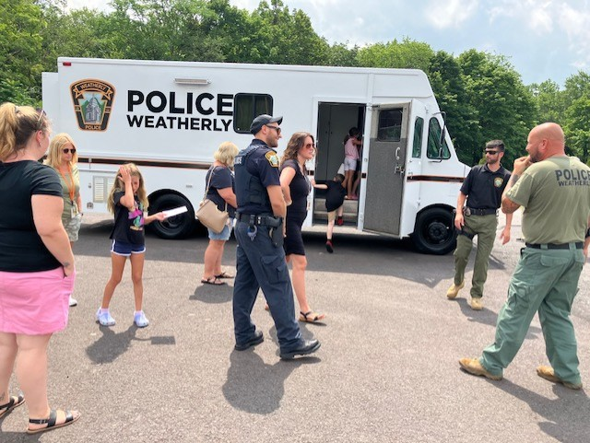

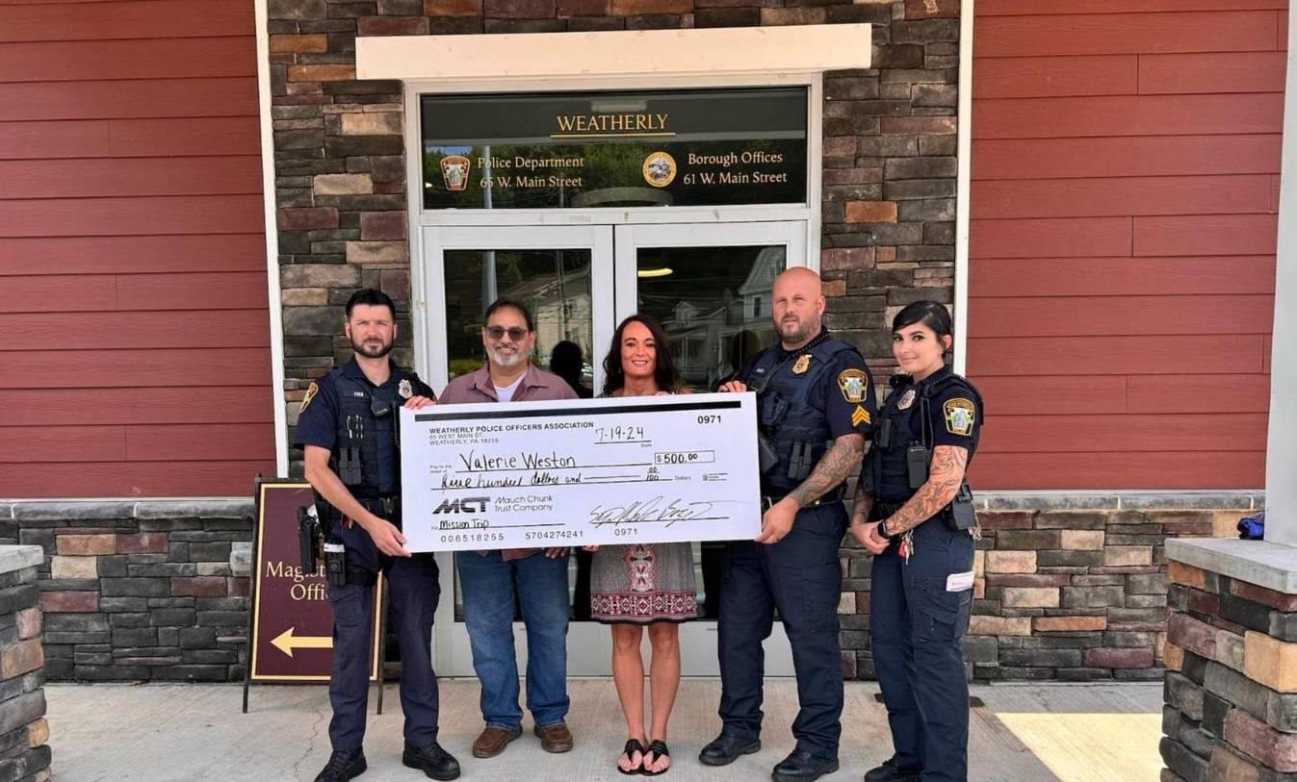


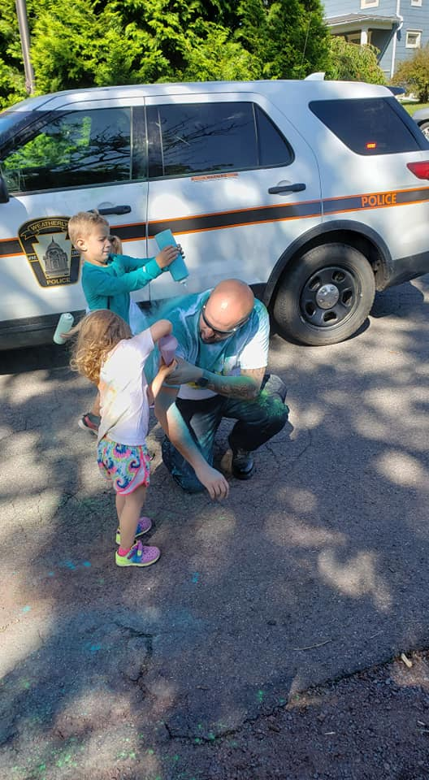

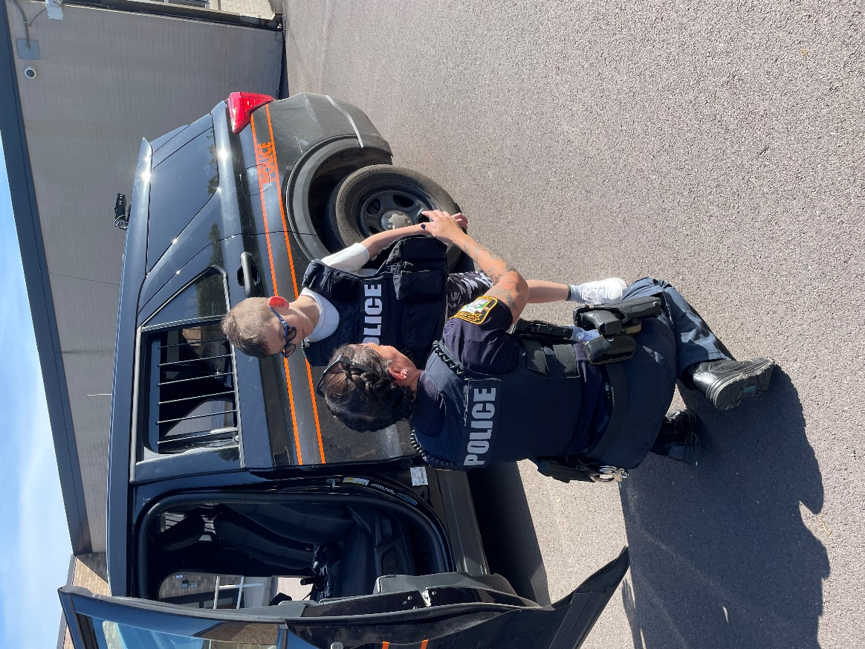

We

Weatherly Borough Police Department
65 West Main Street
Weatherly, PA 18255
570-427-4241

65

